ILLICIT DISCHARGE CONTROL ACTIVITIES

ILLICIT DISCHARGE CONTROL ACTIVITIES

QUALITATIVE RESULTS

Municipality: Contra Costa County (Unincorporated) Permit Year: 2008/2009

Introduction:

The County Watershed Program (CWP) is responsible for overseeing illicit discharge control activities within the unincorporated areas of Contra Costa County in order to ensure pollutants are not discharged to the storm drain system. In unincorporated Contra Costa County, the storm drain conveys untreated stormwater and urban runoff to the local creeks and other waterways. In East County, these waterways discharge to the Delta; and in West County to the Carquinez Strait, San Pablo Bay, and the San Francisco Bay. The water’s final destination, of course, is the Pacific Ocean.

The CWP manages the County’s illicit discharge program, with the assistance of Public Works Maintenance Division, Contra Costa County Flood Control & Water Conservation District (FCD) and other Departments, so that stormwater pollution in urban runoff, including sediment, trash, pesticides and hydrocarbons, are minimized and ultimately eliminated. Many County departments often become involved in the notification, investigation, and corrective action of illicit discharges. This Permit Year (PY) 2008/09, CWP partnered with the following other Divisions and Departments located throughout the County to cooperatively tackle some significant and recalcitrant cases:

- Health Services Department’s Hazardous Materials Division (HazMat)
- Health Services Department’s Environmental Health, Solid Waste Code Enforcement
- Health Services Department’s Environmental Health, Planning (Sanitary Sewer Overflows)
- Conservation and Development Department, Building Inspection, Code Enforcement
- Sheriff’s Office of Emergency Services (OES)
- Environmental Crimes Unit of the District Attorney’s Office (DA)
- CA Emergency Management Agency (CalEMA)
- CA Highway Patrol
- CA Department of Fish and Game (CA DF&G)
- National Response Center (NRC)

The Illicit Discharge Control Activities (IDCA) Program works to eliminate illicit discharge activities by responding to complaints, screening the County’s municipal separate storm sewer system, performing field investigations, sending written notification to violators, providing technical assistance about corrective action to dischargers, referring to appropriate enforcement agencies, ensuring cleanup is completed and raising the awareness of our citizens and businesses about stormwater pollution prevention and protection of our watersheds.

This PY 2008/09, CWP and HazMat responded to a total of 113 illicit discharges that threatened the storm drain system in comparison to 103 illicit discharge complaints investigated in PY 2007/08.

Most of the incidents were brought to our attention by complaints, referrals, and tips. The majority of the illicit discharge notifications received by CWP staff were referrals from our Public Works Maintenance Division Flood Control crews, who perform MS4 screenings and maintenance of approximately 75 miles of improved channels, which are constructed of earth, rip-rap, grouted rip-rap, and concrete. The improved channels are divided into drainage zones, throughout the County, and include sections within some incorporated cities. The crew also maintains Countywide drainages comprised of smaller dedicated drainage facilities, mostly natural waterways in the unincorporated parts of the County. FCD also maintains four dams, 35 detention basins, and 25 trash racks.

FCD is charged with ensuring our County’s improved and natural flood control channels are maintained and remain free from blockages so that they have adequate capacity to convey storm flows. Lined channels and culverts efficiently convey stormwater downstream, but also move contaminants along with minimal treatment. FCD crews conduct fieldwork, which brings them in close proximity to clean water violations. Many incidents are worked out with the property owner, but in some cases, when FCD crews are unable to identify/locate the owner or if they are dealing with recalcitrant and repeat violators, they will bring the discharge to the attention of CWP.

FCD crews commonly encounter abandoned dirt piles and other yard waste on creek banks and access roads, landslides on private property creek banks, green waste that has been improperly disposed of to creeks, unmanaged riparian vegetation and downed trees, and illegal dumpsites of solid waste, construction debris, furniture, appliances, e-waste, and household hazardous waste.
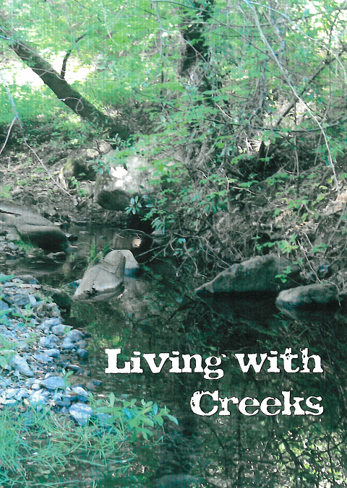
One-third of the illicit discharges investigated by the CWP during PY 2008/09 involved soil, green waste, construction debris, and solid waste. Many of the incidents were attributable to residents fortifying their creek bank with bricks and concrete or disposing of their vegetative waste on creek bank to suppress weeds. In reality, these activities compact the riparian zone and create more downstream erosion and increase sediment loads in waterways by altering the stream bank.

To address these types of illicit discharge problems, the CWP began developing a Living with Creeks brochure in PY 2007/08, which we completed and distributed in the fall of this PY 2008/09 prior to the rainy season when the majority of illicit discharge calls are generally received. The brochure was sent to over 6,400 property owners in the unincorporated areas of the County whose parcels abut creeks or have creeks flowing through them. The brochure will educate property owners about their responsibilities for creek maintenance and care. More information about efforts to educate the public as an effective deterrent to illicit discharges can be found in the Public Education & Industrial Outreach (PEIO) Section of this Annual Report.

Although the number of illicit discharge complaints and referrals we received this PY 2008/09 is slightly larger this year than last, 113 vs. 103, we believe in the effectiveness of our various public education and outreach efforts aimed at reducing illicit discharges. These include CWP’s compliance programs:
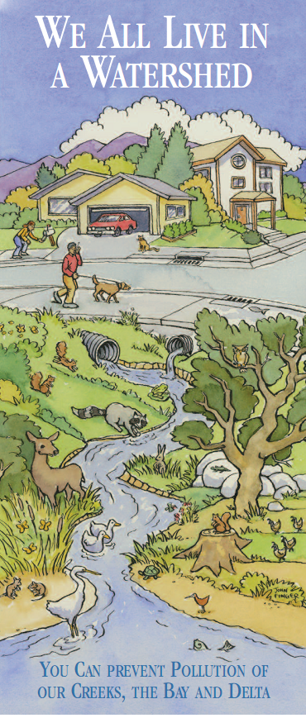
- Storm Drain Marker Program
- Equestrian Compliance Program
- Keep the Delta Clean Program
- Annual Watershed Calendar

Along with numerous public outreach publications that we have mass-mailed, we also include general watershed awareness and pollution prevention brochures with each illicit discharge Notice of Violation letter that we send out, including:

- We All Live in a Watershed
- After the Storm: A Citizen’s Guide to Understanding Stormwater
- Living with Creeks

We also have targeted publications specific to different discharge types, many of which will be discussed in more detail later in this IDCA Section of the Annual report. Examples of specific illicit discharge educational pieces include:

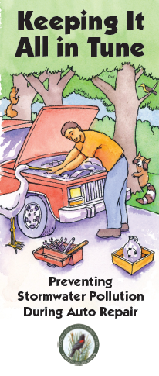
- Pools and Spas (Pool Draining)
- Oil Spill Notification Postcard (Oil Spills to Water)
- Keep It All In Tune (Auto Related)
- Trash Best Management Practices for Businesses (Trash)

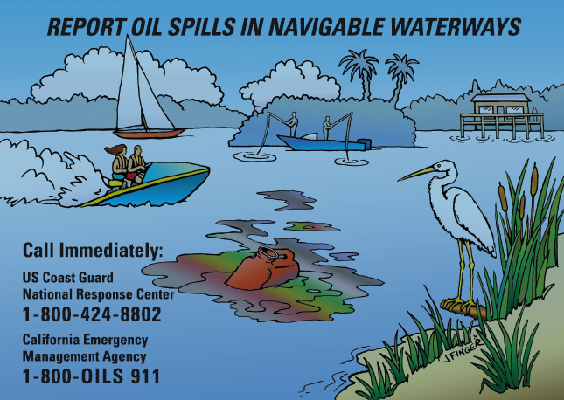

Other useful stormwater pollution prevention publications that the IDCA Program distributes with many of our warning letters and Notice of Violation letters are produced by the three Household Hazardous Waste (HHW) Facilities serving our County. The goal is to make residents aware of existing disposal facilities in order to encourage proper disposal of their wastes and eliminate illicit discharges. Click on each option below to see the HHW/Recycling publication we hand out on behalf of RecycleMore.com:

- West County HHW
- Contra Costa Central Sanitary HHW
- Delta Diablo HHW
- Used Oil Collection Centers (West County)

The CWP continues to respond to illicit discharge complaints and conducts outreach to encourage responsible practices for commercial and private horse facilities. The emphasis of the CWP’s Equestrian Facility Compliance Program is to educate horse boarders and horse owners of the importance of proper horse-keeping methods in order to minimize the stormwater impacts associated with this activity that has a high potential to generate illicit discharges. During PY 2008/09, CWP reviewed our address lists and organized recipients in previous mailings into separate spreadsheets. We were then able to locate an additional set of 39 horse operations throughout Contra Costa County, which we outreached to in April 2009 with our equestrian mailer.

The CWP has also been busy this year with the continued implementation of our marina and recreational boating program called, “Keep the Delta Clean. You Play In It, You Drink It, Too!” This year the Keep the Delta Clean (KDC) Program, implemented by the CWP (in partnership with neighboring jurisdictions in the Delta area), distributed over 3,421 Boater Kits. The Boater Kits contain outreach materials intended to help eliminate marine related oil and fuel discharges and to promote environmentally sound boating habits.

To date, over 15,000 Boater Kits have been distributed to the Delta boating community through both phases of the KDC Program. Three used oil recycling centers have been established in East Contra Costa County through the KDC Program and have been certified by the Department of Toxic Substances Control. Additionally, the KDC Program funds oil absorbent programs at five marinas. Through this program, oil absorbents are distributed to boaters for free and are also collected for free once they are used. The KDC Program is currently in Phase II, which involves expansion into four additional Delta counties.

Please contact Charmaine Bernard at (925) 313-2236 or by e-mail at cbern@pw.cccounty.us for more information about the County’s IDCA Program and Dan Jordan at (925) 313-2023 or by e-mail at djord@pw.cccounty.us for more information about the KDC Program.

Implementation & Evaluation:

Analysis of Stated PY 2007/08 Annual Report Goals for PY 2008/09

- Explore methods to better track illicit discharges utilizing GPS and/or GIS technology. Secure funding for additional equipment necessary to fully utilize this technology.

Although our Maintenance field crews do not employ GPS, CWP does have access to a hand-held unit and has been using it to pinpoint our watershed signs. In addition, our GIS Division is in the process of rolling-out a new software application for mapping various data points. In the trial phase, they used CWP’s illicit discharge data. Look for more information, including trend maps, for previous Permit Year discharges in next year’s Annual Report.

2. Explore grant opportunities and seek potential funding options in order to enhance IDCA abilities. Our program is currently pursuing several different projects and exploring funding options.

During PY 2008/09, CWP applied for an EPA grant (San Francisco Bay Area Water Quality Improvement Funds) from the San Francisco Estuary Partnership. The grant will be to begin the first phase of a two-phase project with the ultimate goal of diverting low flow discharges from the North Richmond Pump Station to the West County Wastewater District (WCWD). The first phase will involve two components: water quality sampling to determine if WCWD will be able to accept stormwater for treatment and a feasibility study to determine how best to route the low flows to the sanitary system.

3. Participate with the Contra Costa Clean Water Program (CCCWP) and provide valuable information for more effective performance standards in the new municipal National Pollutant Discharge Elimination System (NPDES) regional permit. The CWP has been working with the CCCWP Water Program to provide recommendations to the Regional Water Quality Control Board (RWQCB) for the new Municipal Regional Permit (MRP).

This is ongoing. The Revised Tentative Order of the MRP was released in February 2009. CWP staff spent a significant amount of time preparing comments, attending public hearings, briefing the County Board of Supervisors and the Transportation, Water and Infrastructure Committee (TWIC), and gathering feedback from affected Departments, Sanitary Districts, and Agencies. We expect to have another round of MRP comments this fall with a hopeful release of a new MRP this upcoming Permit Year.

4. Continue to develop close working relationships with the Public Works Maintenance Division and FCD in order to be notified of illicit discharges and drainage blockages so that CWP staff has the opportunity to follow through in issuing Notice of Violation warning letters to dischargers and technical assistance for appropriate corrective actions in order to resolve the release/incident.

This is ongoing. Contra Costa County Public Works Department (PWD) Maintenance Road and Flood Control Crews are on the “front lines” and are often our first source of information about drainage blockages and illicit discharges. They routinely conduct MS4 screenings via the Catch Basin Inspection and Cleaning Program and routine inspections during maintenance of our County’s flood control facilities. CWP is dependent on field crews for bringing this information to our attention so that we can notify and educate dischargers in order to eliminate the discharge.

5. Continue to develop close working relationships with other County Departments, including Health Services Hazardous Materials, Environmental Health Solid Waste, and Department of Conservation and Development, and Property Conservation Division (Code Enforcement), in order to streamline our County response to and enforcement process for illicit discharges and illegal dumping incidents.

This is an ongoing challenge. Although many County Departments become involved in illicit discharges that threaten storm/surface water, the County has historically been structured such that each Department charged with their primary function, operates independently. This has presented challenges in that the CWP is not always notified of certain types of releases. For example, in the case of sanitary sewer overflows (SSOs) the Sanitary Districts are required to notify the CalEMA, who in turn notifies the County’s Environmental Health entity, which in Contra Costa is the Health Services Department, Environmental Health, Planning Division. There is no formal requirement in place for Environmental Health to notify CWP of SSOs. However, CWP staff has developed relationships with individuals from different County Departments who, for more significant releases, will often include CWP in their updates/distribution lists.

A similar frustration occurs with hazardous waste discharges, such as traffic accidents resulting in fuel spills to the storm drain. The Responsible Party is required to notify CalEMA, who in turn notifies Health Services Department, Hazardous Materials Programs (HazMat), who represents the County and most incorporated cities to mitigate the discharge. However, they have no official obligation to notify CWP of spills to surface or stormwater. They do, however, report these responses to CWP quarterly as part of our Interdepartmental Agreement. Often the first that we become aware of these incidents is when the RWQCBs inquire to CWP about the incident. (Note: RWQCB is also receiving “back door” notification of incidents from CalEMA.)

CWP is in the challenging position of enforcing our MS4 NPDES permit requirements for illicit discharges that HazMat often finds out about well after the discharge has occurred or on a “need to know basis.” We will continue to look for opportunities to improve our awareness of spills and discharges to the environment, but unless notification changes are made at the State level and CWP is deemed necessary to be included on CalEMA’s notification list, we will do our best to follow up on incidents that we have been informed of. This requires that staff stay on top of developing news of hazardous releases, spills, and illicit discharges; increase contacts at other Departments; and request that they forward notices of illicit discharges to the storm drain system as they encounter them. They also continue to train inspectors about CWP’s function and encourage use of the BMP Car Kits, which include CWP business cards and general information about who to contact for illicit discharges to the storm drain system.

The bottom line is that our County Departments can work together to ensure that the proper exchange of information is taking place, but as a County, we are not set-up to act in a streamlined manner. For many discharges that CWP has been involved in, we respond along with other PWD Divisions, Sanitary Districts, HSD HazMat, and/or Environmental Health staff, as well as the Department of Conservation & Development (DCD) Building Inspectors and even the DA. This “in mass” response by multiple Departments often sends the message “home” to dischargers that we are taking their action seriously and that they are facing pressure from many directions, which often results in more immediate corrective action.

6. Continue to develop close working relationships with the District Attorney’s Environmental Task Force in order to successfully enforce against willful and chronic dischargers.

CWP just received notification that our main field contact at the DA’s Environmental Crimes Unit will leave the County on medical retirement within the next few months. He has been very instrumental in tracking recalcitrant violators and helping CWP gain corrective action prior to having to engage in a lengthy enforcement process, during which time the environment often suffers. CWP looks forward to beginning to work with his replacement in future illicit discharge investigations.

7. Continue to develop a close working relationship with the CA DF&G’s three wardens operating in our County for assistance in conducting field visits, handling enforcement of responsible parties who engage in non-permitted streambed alterations and polluting activities.

This PY 2008/09, CWP has not had much success interacting with our game wardens other than at the Annual Fish and Wildlife Committee BBQ each fall. This year, we have felt particularly distant from CA DF&G staff with the institution of the third furlough day for State employees. We continue to copy the appropriate warden on correspondence to discharges that include pollutants to natural waterways or stream bank alterations, although we have not received notification of their follow up for any of the illicit discharges that we have shared with them.

8. Continue to develop close working relationships with the RWQCBs in order to be available to respond timely to illicit discharge referrals from the State.

This has been done. CWP prioritizes inquiries/referrals from RWQCB at a very high level and strives to provide them with timely and complete information.

9. Continue to work closely with the three East Contra Costa County marinas to support their new oil recycling centers and promote responsible boating practices. The oil recycling centers have proven to be very effective.

This is ongoing. As part of the KDC Program, CWP agreed to fund used oil recycling centers at Discovery Bay Yacht Harbor, Lauritzen’s Yacht Harbor, and Sugar Barge Marina for a period of twenty years. During PY 2008/09, 2375 gallons of oil were collected for recycling from these three sites.

10. Continue to distribute “Get Rid of It” paint brochures. The Program has continued to distribute brochures, and the amount of paint received by public Household Hazardous Waste (HHW) sites has continued to increase.

This is ongoing by HazMat as part of our pollution prevention outreach campaign. This year, HazMat sent out 4,250 paint brochures to paint retailers and hardware supply stores throughout the County.

11. Continue to mark storm drains as much as possible while student workers are available for the summer.

Student Workers continued their third summer of inspecting, mapping, and applying storm drain markers on every public catch basin in the unincorporated areas of the County. In PY 2008/09, 2,368 storm drain markers were installed –reinstalled, bringing the total of new storm drain markers applied to 4,845.

12. Work with the Clean Water Managers of Contra Costa cities via CCCWP to encourage them to enforce their ordinances along the County’s flood control channels that flow through their jurisdiction.

This is ongoing. This is being handled on a case-by-case basis as discharges occur to our County’s Flood Control channels from point sources within city jurisdictions.

13. Continue to work with CA DF&G and County Code Enforcement to target illicit discharge problem areas.

As a proposed requirement of the MRP, CWP will continue to work with Flood Control and other Departments to identify dumping hotspots and target illicit discharge problem areas.

14. Continue to work with Public Works’ Transportation/Traffic Division to implement parking restrictions along Forni Drive in North Concord. This area is a problem due to oversized, leaking, and transient vehicles being parked overnight for extended periods resulting in threats to stormwater quality.

This has been done. “No Oversized, No Overnight Parking” signs were installed along Forni Drive on 11/19/08. Businesses in the vicinity were so pleased with the decrease in the number of parked cars along Forni Drive that they requested the signage be expanded to Dean Lesher and Anna Lisa Drives. CWP outreached to all parcel owners and businesses for their support of the proposed parking restrictions. After several months of seeking community interest via letters and a survey sent on February 18, 2009, approval was granted by the Board of Supervisors on April 7, 2009, and signs were installed at the end of May. Thank you notes were sent to all survey participants.

Illicit Discharge Control Activities During PY 2008/09:

Illicit Discharges by CWP

As part of our MS4 NPDES permit, CWP is charged with ensuring that our storm drain system, which includes ditches, curbs, gutters, storm sewers, and similar conveyances of runoff that are not connected to wastewater treatment, is protected from illicit discharges by:
1. Prohibiting non-stormwater discharges into the storm drain system. Note: stormwater includes surface runoff and discharge.
2. Implementing controls to reduce the discharge of pollutants to the maximum extent practicable.
3. Including control measures or programs that detect and eliminate illicit discharges or non-stormwater discharges.

This PY 2008/09, CWP responded to many of the same types of illicit discharges as in previous years, including sanitary sewer overflows, wash water, automotive fluids, vegetation, trash and debris, pool discharges, saw cutting, and horse manure. In addition, we continued our joint sampling study at the Diablo County Club golf course with the golf course management and Town of Danville to determine if there are any impacts from off-site migration of fertilizer and/or algaecide products used in the golf course ponds and on the greens and fairways. Click on photos to view the February 19, 2009 sampling session. Look for the final report for this project in the PY 2009/10 Annual Report.

Some of the more significant illicit discharge incidents we worked on in
PY 2008/09 included:
- Trash on the banks of Grayson Creek from dumpsters left open during business hours. This required dealing with issues of responsibility between the property management company, property owner, and numerous restaurants in a Pacheco mini-mall.
- Broken waterline for a fire suppression system located underground at the base of a 22-foot retaining wall at the County’s Juvenile Hall. This caused tap water to discharge to the storm drain system running through PWD’s property for several weeks until the source could be located and complex repair could be made.
- Issues with more abandoned homes going into foreclosure and banks dealing with a backlog of properties to maintain where property owners or vagrants squat, but are unwilling to deal with clogged lateral lines that cause sanitary sewer overflows to our County’s gutters and storm drains.
- Natural seep in Kensington causing algae growth along several miles of continuously running water. CWP wrote an article for Kensington’s Municipal Advisory Committee’s newsletter educating them about this natural discharge and providing contact information for East Bay Municipal Utility Department (EBMUD) for permitting for potential capture of this constant water source.
- Illicit discharge investigation and referral to DA’s office for potential enforcement case against EBMUD following their disposal of turbid water from emergency repairs to drainage inlet leading to San Pablo Creek.
- Older pools at community centers, apartments, or homeowners associations located in established neighborhoods having filter backwash lines that are plumbed to storm drains/creeks.

As observed during PY 2007/08, a majority of the illicit discharges reported to the CWP this Permit Year occurred in residential areas. Of the 83 illicit discharge notifications investigated by the IDCA Program, nearly two-thirds (53) of the discharges occurred in residential areas, while approximately one-quarter (22) of the discharges occurred at commercial properties. The remaining 10% (8) occurred at industrial areas compared to only three incidents involving industrial sites in PY 2007/08.
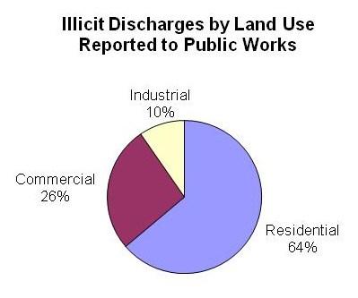
The relatively high occurrence of discharges in residential areas re-emphasizes the importance of continuing public education outreach efforts. Hopefully, behavioral change can occur by informing residents about the detrimental effects of illegal dumping and illicit discharges to the storm system. Of the 83 illicit discharge incidents, 34 were followed up with written Notice of Violation letters requiring corrective action.
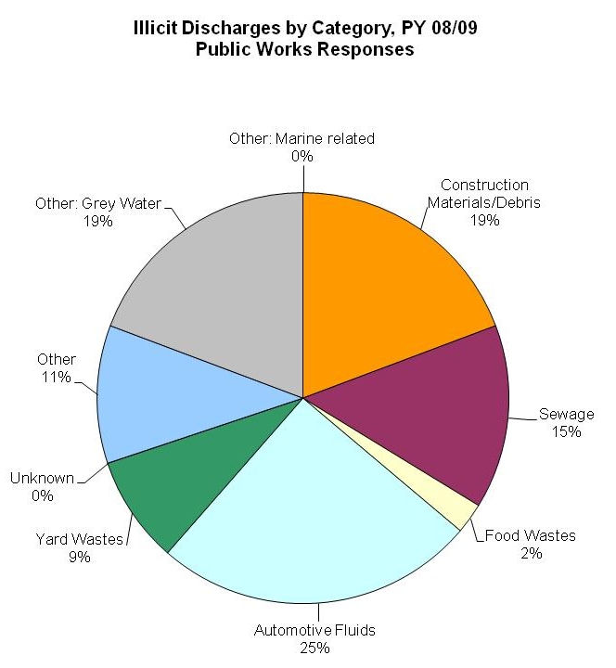
During PY 2008/09, the most common four types of discharges responded to by CWP staff (in order of prevalence by category) were: Automotive Fluids (21), Construction Material/Debris (16) and Grey Water (16) and Sewage (12), which included sanitary sewer overflows as well as manure from horse boarding facilities. We continue to educate dischargers of yard wastes (7) that even organic materials like green waste, mulch, wood chips, or dead weeds are considered pollutants when discharged to waterways and can negatively impact water quality.

October and November were peak response months for CWP in 2008 with 12 responses. January 2009 with ten responses and June with eight responses to illicit discharges were also peak months.

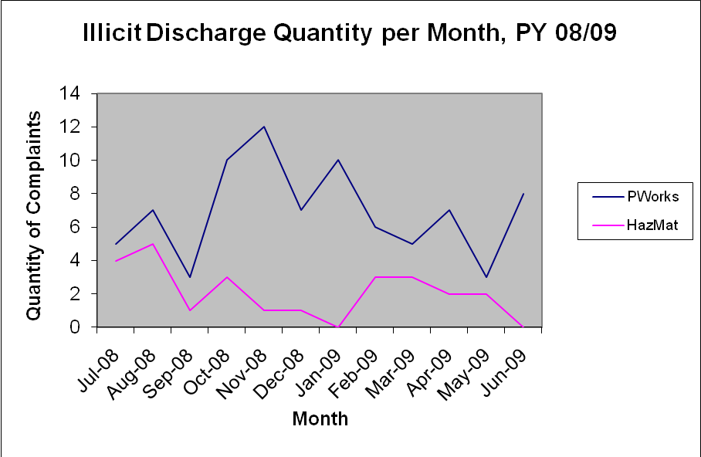

One issue to note from our reporting on illicit discharge data is that there appears to be an inconsistency between how types of discharges are handled due to our limited reporting categories incorporated in the illicit discharge reporting template. For example, different data entry staff may categorize certain discharges unspecified into different categories. This makes it difficult to compare discharge types responded to by CWP and HazMat as well as analyze for trends in type over Permit Years. We hope that with the execution of the MRP, we will be required to report illicit discharges under a different reporting template. Ideally this template will create more categories for different discharge types that will eliminate confusion between unspecified releases like pool water (Other or Grey Water), oil spill to navigable waterways (Other: Marine Related), abandoned chemicals like drums of household hazardous waste containers (Construction Debris or Other), and sediment/erosion (Construction Debris).

Illicit Discharges by HazMat

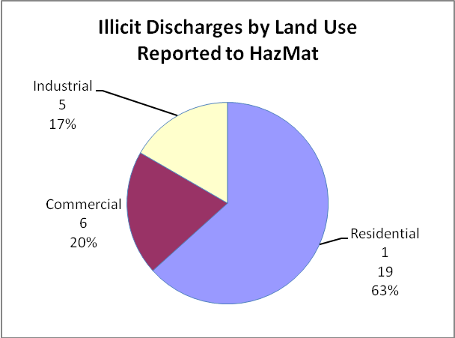
During PY 2008/09, CWP referred several incidents that involved automotive fluids, chemicals, or hazardous waste to HazMat. As the lead agency for responding to hazardous materials releases in Contra Costa County, HazMat also received notification of discharges that threatened the storm drain and/or surface water directly from CalEMA and the Department of the Sheriff’s Office of Emergency Services (OES). In total this PY 2008/09, HazMat responded to 30 illicit discharges. HazMat recorded no responses in December 2008, May and June 2009. Of the 30 illicit discharges responded to by HazMat, 63% (19)
occurred at residential properties in contrast to last PY 2007/08 in which the highest percentage occurred at industrial facilities. 20% (6) of HazMat’s responses were at commercial properties while 17% (5) occurred at industrial facilities.

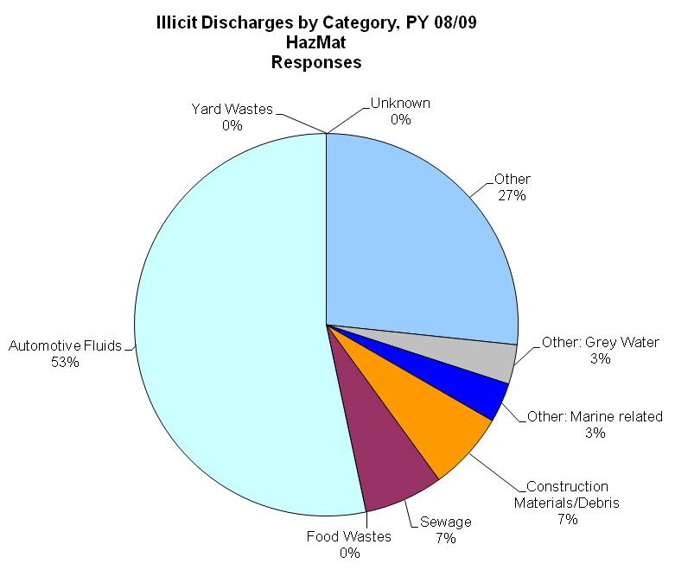
The most frequent type of discharge responded to by HazMat, as expected, involved automotive fluids (16) from traffic accidents and the incidental release of petroleum fluids being spilled into the storm drain system, resulting in about one-half of all HazMat’s illicit discharge responses. The second most common category of discharges addressed by HazMat was “Other” (8). This category included responses to abandoned drums and containers of chemical waste, such as paints and solvents, as well as hypodermic needles.

For more detail about CWP and HazMat’s Illicit discharge responses, click on the Master Illicit Discharge Investigation. One noteworthy item involved the distribution of illicit discharges in El Sobrante (15), Martinez (15), North Richmond (11), Pacheco (11), Bay Point (9), San Pablo (7) and Walnut Creek (8). This data can be used for future illicit discharge targeted outreach to these communities.

Area | PW | HazMat | Total
Alamo | 6 | 0 | 6
Antioch | 1 | 0 | 1
Bay Point | 3 | 6 | 9
Briones | 1 | 0 | 1
Bethel Island | 0 | 0 | 0
Brentwood | 0 | 0 | 0
Byron | 3 | 1 | 4
Carquinez Strait | 0 | 0 | 0
Clayton | 1 | 0 | 1
Clyde | 2 | 0 | 2
Concord | 4 | 1 | 5
Crockett | 1 | 1 | 2
Danville | 0 | 0 | 0
Delta | 0 | 0 | 0
Diablo | 1 | 0 | 1
Discovery Bay | 3 | 0 | 3
El Sobrante | 11 | 4 | 15
Kensington | 1 | 0 | 1
Martinez | 11 | 4 | 15
N. Richmond | 10 | 1 | 11
Oakley | 0 | 0 | 0
Pacheco | 9 | 2 | 11
Pleasant Hill | 2 | 0 | 2
Pleasanton | 0 | 0 | 0
Port Costa | 0 | 1 | 1
Richmond | 0 | 2 | 2
Rio Vista | 0 | 1 | 1
Rodeo | 0 | 2 | 2
Sacramento | 0 | 0 | 0
San Francisco | 0 | 0 | 0
San Pablo | 4 | 3 | 7
San Ramon | 1 | 0 | 1
Walnut Creek | 8 | 0 | 8

Oversight of Planned Discharges of Potable Water

During PY 2008/09, the FCD began to oversee discharges of potable water, per the San Francisco RWQCB’s January 8, 2009, “Interim Guidance for Planned Discharges from Potable Water Sources.” The County primarily reviewed discharge requests by water providers for purposes of ensuring that the plans incorporated BMPs adequate to ensure that chloramines would be removed and erosion would be prevented. The FCD’s primary focuses, however, were to ensure that the channels that would convey the water had adequate capacity to handle the discharges, that there was no work being conducted within flood control facilities that might be compromised by the increased flow, and that Flood Control staff was aware of the discharges and did not waste staff time investigating the sources of larger-than-expected flows that might be reported by concerned citizens. While the County was primarily concerned with discharges that would be conducted from within (or would drain across) unincorporated portions of the County, the FCD was concerned with any discharge that would be conveyed by a FCD Facility.

The County and FCD jointly considered nine separate notifications of planned discharges. The Contra Costa Water District submitted five notifications of planned discharges, each covering one discharge location. EBMUD also submitted five notifications of planned discharges, but these comprised a total of 19 distinct discharge locations (with larger dewatering projects requiring coordinated discharges across multiple points along a given facility).

Although information provided by the water districts was ultimately satisfactory in every case, information initially submitted with requests was inadequate in several instances and did not provide County and FCD staff with sufficient information to determine whether there could be negative impacts associated with the planned discharges. In some instances, the water districts notified the County and FCD of such planned discharges as little as one day prior to the tentative discharge date. Although this is inconsistent with the minimum notification time required in the Water Board’s interim guidance, the County and FCD made all reasonable efforts to accommodate such requests if it could be determined that the discharge was acceptable. The two discharges observed by staff did not cause any concern as discharges were conducted in a responsible manner with appropriate BMPs implemented.

Although none of the planned potable water discharges were problematic, the County and FCD do object to overseeing such discharges on an ongoing basis (as was proposed by the most recent iteration of the MRP). Among the most significant concerns of the County and the FCD are that it is not entirely clear whether the County and/or FCD currently wield regulatory oversight over water districts. Also, both agencies’ staff expended numerous hours processing these requests to discharge potable water, including reviewing plans for discharges and seeking necessary clarifications, conducting inspections, and reviewing summary reports. Neither agency currently has a mechanism to recoup costs associated with time spent on these activities. The County and FCD, therefore, propose that such activities be covered by the water district’s (and other agencies conducting planned discharges of potable water) individual NPDES permits or that a General Permit for Planned Discharges of Potable Water be issued by the Water Boards. Any program of this sort should still require the dischargers to notify local jurisdictions and flood control districts, which should have the opportunity to make comments on requested discharges and to request that the Water Boards deny and/or condition such requests in order to prevent conflicts with water quality and/or flood control goals.

Used Oil & Filter Recycling Outreach and Collection Programs

Summary data was provided by the Department of Conservation and Development related to the Used Oil & Filter Recycling Outreach and Collection Programs, which we administered in PY 2008/09. These Programs were either fully funded for Collection Programs via Richmond Sanitary Service and Garaventa or partially funded for Outreach Programs including, Transit Bus/BART Posters with the Used Oil Block Grant funding provided by the CA Integrated Waste Management Board for the unincorporated areas of the County and the City of Oakley.

One hundred Transit Bus/BART posters were posted on cars associated with AC Transit (West County), County Connection (Central County), Tri-Delta Transit (East County), and WestCat (Regional Service) targeting an estimated rider population of 14,216,640 during the one month advertisement period mid-May to mid-June 2009 for the cost effective price of over $27,000. During the first three quarters of this PY 2008/09 for which we have oil collection data, 370 used oil containers were mailed and 448.5 gallons of oil were recovered from the communities of Richmond, Discovery Bay, unincorporated Brentwood, Byron, Oakley, Knightsen, Bethel Island, and Bay Point. These oil collection programs assist homeowners from rural communities by providing a cost effective service that recovers a significant volume of oil from the environment.

Equestrian Facility Compliance Program

CWP continues to implement the Equestrian Facility Compliance Program that was established during previous permit years. CWP continues to recognize the need to conduct outreach to commercial and private equestrian facilities within the unincorporated areas of the County to educate horse owners about stormwater pollution prevention. It was determined that horse boarding facilities were a previously underserved group that potentially pose a significant threat to the water quality of local creeks and waterways, due to improper manure management, erosion, paddock care, fly abatement chemicals, and poor stable housekeeping.

This PY 2008/09, CWP began a third phase of mail-outs, including an informational letter to equestrian facility managers in April 2009 accompanied by the brochure Horse Owners Guide to Water Quality Protection, in order to educate these facilities’ owners and managers about conservation practices that protect water quality. After spending some time updating our Master List of private and commercial equestrian facilities, we were able to identify 39 operations that had not been outreached to during previous mail-outs.

In addition, anytime CWP receives notification of issues at equestrian facilities, we now mail out our Notice of Violation letter along with our Stormwater Pollution Prevention for Horse Boarding Facilities folders, which are filled with numerous publications related to horse operations and Best Management Practices (BMPs) for protecting stormwater. The folders contain the following brochures, fact sheets and articles:

- Horse Owners Guide to Water Quality Protection
- Portable Backyard Garden
- Conservation Measures to Reduce Non-point Source Pollution at Horse Facilities
- Dryland Pasture for Horses
- Horse Manure Management
- Controlling Yellow Starthistle
- Stormwater Runoff Management for Buildings and High Use Areas
- Horse Paddocks: Designed and Managed to Protect Water Quality
- Composting Horse Manure
- Program Background
- Riparian Buffers
- Humus, sweet humus
- Environmentally Sensitive Horsekeeping
- Pollution Control for Horses Stables and Backyard Livestock
- 5 Great Ways to Conquer Mount Manure

Those equestrian facilities cited for illicit discharges are added to CWP’s future inspection list and later investigated to ensure corrective action measures have been taken.

The CWP’s experience in inspecting and working with horse facility managers reveals the majority of them want to do the right thing, but they generally do not know how to modify their practices in order to better safeguard watershed health. The Equestrian Facility Compliance Program has facilitated a dialogue between the CWP regulators and potential polluters by fostering partnerships with local equestrian facility managers to protect our local waterways.

Streamside Management Program for Landowners

The CWP continued to support the Streamside Management Program for Landowners (SMPL), with guidance provided by the Urban Creeks Council (UCC) and joint funding from co-permittees through the CCCWP. During the first quarter of PY 2008/09, SMPL staff worked with two property owners in the unincorporated area of the County who took advantage of this great opportunity to receive a free consultation about their unique creek situation. One involved a property owner losing land in a slide on the Eastern Branch of Green Valley Creek within the Byron Ranch Homeowners Association due to lack of maintenance at the upstream detention basin. The other involves a property owner at upper Las Trampas Creek who continues to be challenged by an entire creek reach in need of restoration.

SMPL continues to present owners with both short and long-term ecologically sensitive solutions to their creekside problems. During the second quarter, UCC supported various watershed groups from Alhambra Creek by attending meetings with the Alhambra Watershed Council (AWC) and the Alhambra Valley Creek Coalition (AVCC) in order to support their grassroots efforts at restoring a one mile section of upper Alhambra Creek, which includes John Muir’s gravesite. The summary of the third quarter UCC consultations included one consultation in the unincorporated County’s area of El Sobrante for erosion control at Indian Creek.

One recurrent theme that the CWP encounters while enforcing the NPDES Permit, as well as County Ordinance Code §1014 Stormwater Management and Discharge Control, is a lack of awareness among property owners of their responsibility to maintain private drainage facilities (creeks) in a manner that prevents pollutants from entering waterways, and their responsibility to ensure that flows are unimpeded by fallen trees and downed limbs per the County Ordinance Code §1010 Drainage. UCC staff was instrumental in supplying CWP with technical information and numerous creek-related publications which aided in the development of our Living with Creeks brochure.

SMPL is a valuable hands-on program that takes into account each participant’s unique waterway situation and tailors solutions to their streamside problem, be it erosion control, bank stabilization, bank-building, undercut banks, stagnant water, etc. They also provide excellent resources about permitting, including the UCC Complete Permitting Guide, which contains information about the “one-stop” permit that will satisfy most creekside permit requirements, the Joint Aquatic Resource Permit Application.

BMP Car Kits with Clean Water Violation Notice & Pollution Notice Door Hangers

The BMP Car Kits continue to be a useful item for field inspectors and CWP staff. They were produced during the last PY 2007/08 and handed out to over 100 inspectors from various County Departments in order to provide them with additional outreach tools following observations of illicit dischargers.

The intent of the Car Kits is to provide inspectors with stormwater publications in English and Spanish that they can handout to educate dischargers in the proper BMPs that they should utilize in their non-permitted activities like construction and landscaping to protect storm drains and eliminate non-stormwater discharges.

One feature of the BMP Car Kit, the “Clean Water Violation Notice” forms (with Spanish translation) offers a quadruplicate (carbon copy) form that allows inspectors to document and maintain a record of the illicit discharges while helping to explain the nature of the violation to the discharger and provide them with written corrective action control measure they should take in order to come into compliance. In addition to the “Clean Water Violation Notice” forms, the BMP Car Kit also contains Pollution Notice Door Hangers with CWP logo and contact information. The door hangers continue to be popular with PWD Maintenance Road Crew Leads, who often leave them at front doors with their business cards.

Car Wash Kit

In PY 2008/09 CWP continued to disseminate outreach about our Car Wash Kits to charity groups described in the PEIO Section of the Annual Report. The kits offer a means of protecting the storm drain system while conducting car washing events for fund-raising. This year, we sent information about the kits to various organizations, such as the First Light Christian Organization in Pacheco, as we became aware of car wash fund-raising events occurring in our jurisdiction. We were also able to loan the car wash kits to several organizations, including the Lafayette Police Department, El Sobrante Christian School, and College Park High School (CPHS) in Pleasant Hill.

All reported success with the kits except for CPHS who had problems with priming the pump which CWP will follow up on to ensure it is working satisfactory. During our experimental trial, we noticed it was necessary to allow the wastewater to reach a certain level in order for the pump to trigger. Lafayette PD reported, following use of the kit, that they have decided to wash their fleet cars at a local commercial Shell car wash, which is the most environmentally
sound and preferred stormwater alternative. CWP will continue to share information about the car wash kits to any interested groups in the hopes of preventing stormwater discharges from fund-raising events.

Oil Spill Notification Postcards

Following several oil spills/sheens around Discovery Bay that resulted in voicemails being left on the CCCWP’s 1-800-No-Dumping hotline that were not received until after weekends and holidays, CWP decided to develop an outreach postcard that would educate parcel owners along navigable waterways about the harmful impacts of oil spills to water and the importance of timely oil spill notification to the appropriate response authorities. The Oil Spill Notification Postcard was developed as a creative way to broadcast notification information for the CalEMA, the National Response Center, and the CWP. The postcard was mailed out to almost 10,000 residents along outer waterways in the County and an additional 5,000 will be included in the Keep the Delta Clean Boater Kits. For more information about this illicit discharge outreach piece, go to the PEIO section of this Annual Report.

Keeping it All in Tune

After responding to numerous illicit discharge complaints of auto repair activities occurring on County roadways by private citizens, CWP felt the need to update a former outreach piece titled Keeping it All in Tune to which we added —“Preventing Stormwater Pollution During Auto Care.” Due to the current economic downturn, more residents are performing their own auto repairs. Field visits confirmed that many of these vehicle activities do not include proper storm drain protection and appropriate automotive waste disposal.

One of the primary goals of this project was to broadcast pollution prevention BMPs to communities with a higher incidence of auto repair activities and illicit discharge complaints in the hopes of giving residents tools they can use to minimize any spills, leaks, or drips to the roadway, storm drain, and environment. Examples of the BMPs outlined in this brochure/poster include changing vehicle fluids over a tarp or pan, using absorbents to cleanup spills, inspecting vehicles for leaks and repairing them, and washing cars at facilities plumbed to the sanitary system. The brochure was mailed out to 8,770 residents in West County’s disadvantaged neighborhoods, and we continue to pass it out at our PWD front desk, the Application and Permit Center, by HazMat, and at other relevant County Departments. For more information about this illicit discharge outreach piece, go to the PEIO section of this Annual Report.

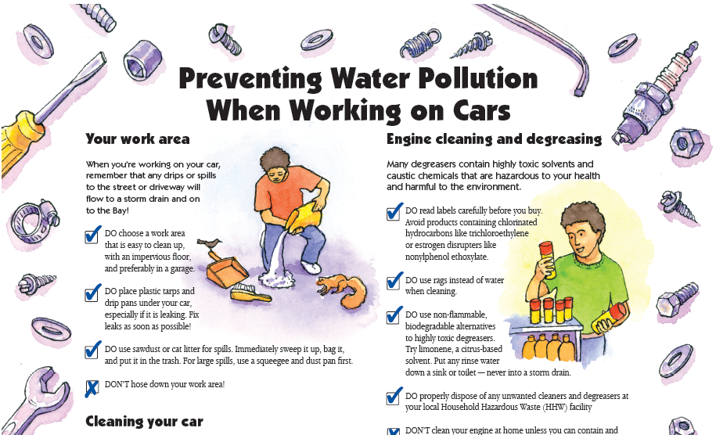
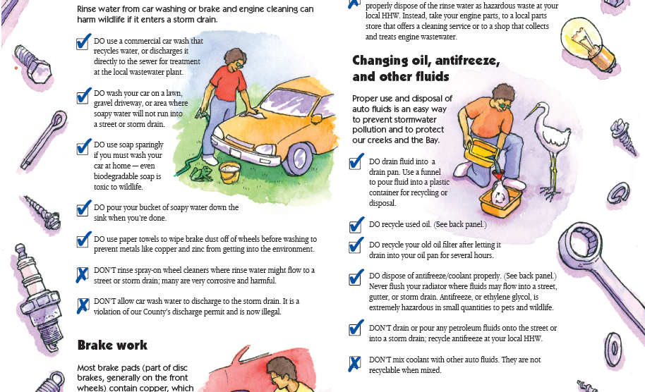
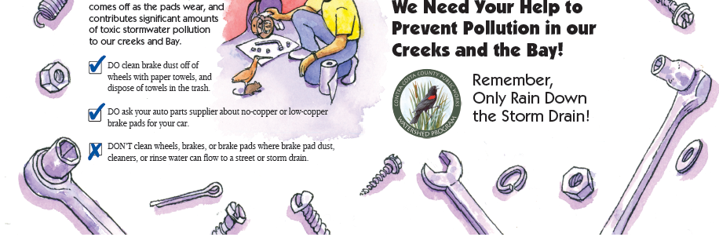

Inspecting for Illicit Discharges

The CWP continues to be challenged by the lack of a dedicated inspector within the CWP program that would be available to respond to illicit discharge complaints in a timely manner. Currently, CWP staff refers field visit requests to various divisions and departments depending on the nature of the discharge and the jurisdictional considerations. For example, staff triages calls and seeks out field staff to investigate priority incidents from several Public Works Divisions. Our Construction Inspectors are divided by region and spend most of their workday out in the field. They can be contacted by cell phone; and, depending on the nature of the project for which they are conducting inspections, they often prioritize the CWP requests such that they are able to perform field visits within a few hours of being contacted.

Maintenance Road Crew Leads are usually busy with prearranged road projects, but when contacted by the CWP with an illicit discharge request, they acknowledge the referrals and are generally able to respond to them within a day or two. They provide pragmatic field knowledge and are familiar with the County’s jurisdiction and navigating the County systems for resolving issues. They are particularly interested in any illicit discharge that may affect health and safety on County maintained roadways (including vehicular accidents, petroleum spills, and the recovery of large items dumped along roadways).

Flood Control Maintenance is also very responsive in investigating illicit discharges, but their priority is maintaining flood control channels, enforcing the 1010 Drainage Ordinance, and directing property owners to remove large items within waterways that may become a flood hazard, including downed trees, dumped appliances, and landslides. Many of the smaller natural drainages that flow through back yards are often not inspected. Unfortunately, these are the location of most of the illicit discharge issues.

Our Department of Health Services, Environmental Health, Solid Waste Code Enforcement has also been helpful in performing field responses for illegal dumps on the roadside and private property, but their ordinance does not allow them to access private property unless it is viewable from a public space. So again, many of the most common dumpsites occurring in back yards along natural waterways are not being proactively identified and cleaned up. CWP continues to work at filling the inspection void. Depending on future budget challenges and redistribution of staff, CWP may be able to hire a dedicated inspector in the upcoming PY 2009/10, which will help the IDCA Program in handling the increased number of creekside illegal dumps that we are beginning to encounter.

CWP is fortunate to have our County HazMat, who responds to any discharges of hazardous substances and requests for stormwater investigations for illicit discharges as requested by CWP and are available 24-hours per day for after-hour emergencies and responses.

Kudos to General Services Department for Eliminating Lead Weights in County Vehicles

We’d like to take this opportunity to share an e-news article by EPA Region 9 <usaepa@govdelivery.com> taken from their press release April 17, 2009, about the successful efforts by our County’s General Services, Fleet Services Division for being the first County in the nation to pledge to remove lead wheel weights from all County fleet vehicles by 2012, thereby removing nearly 2,000 pounds of this heavy metal from the environment. CWP congratulated them for their Pollution Prevention efforts, which came just in time for 2009 Earth Day. US EPA and the County also hosted a media event on April 17, 2009, to demonstrate their operations and their environmental leadership:

“Visual Media Opportunity Today in Mechanic’s Vehicle Maintenance Garage”
(San Francisco, Calif. — 4/17/2009) In an effort to highlight and celebrate Earth Day and as part of the National Partnership for Environmental Priorities program, the U.S. Environmental Protection Agency today honors Contra Costa County for its commitment to voluntarily replace all lead wheel weights from thousands of tires, resulting in a reduction of more than 2,000 pounds of lead from the environment by 2012.
Contra Costa is the first county fleet in the Pacific Southwest to enroll in this program.
“Contra Costa County will prevent thousands of pounds of hazardous lead from entering our environment,” said Tom Huetteman, the EPA’s Waste Division associate director for the Pacific Southwest region. “The county’s environmental leadership serves as a model both for public and private fleets to get the lead out.”
It’s not only large public fleets that can make a difference. Every Bay Area motorist can easily have an impact by requesting non-lead wheel weights when getting their tires balanced.
“As Earth Day 2009 rapidly approaches, we want to let everyone know that this is one small action that consumers can also take to protect the environment,” added Huetteman.
Within one year, the Contra Costa County’s vehicle maintenance facility in Martinez performs nearly 1,800 tire balancing services. By replacing lead weights with coated steel weights, the county will effectively reduce the amount of lead by 2,000 pounds by 2012. This Contra Costa county project serves as a model for other county or municipal fleets.
Background Information
The EPA’s lead-free wheel weight initiative engages partners in the manufacture, distribution, sale and use of wheel weights to participate in a voluntary effort to accelerate the transition to steel
weights. Lead can enter the environment and create potential human exposures by weights falling off tires and being washed into storm sewers or waterways.

Quick Facts:
• Wheel weights are clipped to the rims of every automobile wheel in the United States in order to balance tires.
• Sale of lead weights will be phased out in California by the end of 2009 under a court settlement between Oakland-based Center for Environmental Health and Chrysler along with the three largest makers of lead wheel weights for the U.S. market: Plombco Inc. of Canada, Perfect Equipment Inc. and Hennessey Industries.
• There are 200 million autos and light trucks on the nation's roadways, with 16 million new autos produced annually in the United States.
• An average of 4.5 ounces of lead is clipped to the wheel rims of every automobile in the United States.
• Approximately 50 million pounds of lead are used annually to produce tire weights worldwide in autos and light trucks.
• It is estimated that 1.6 million pounds of lead are lost annually in the United States when wheel weights fall off during normal driving conditions (e.g., hitting a pot hole).
• Local service stations may have steel weights available, and consumers can request them in lieu of lead weights.

The National Partnership for Environmental Priorities encourages public and private organizations to form partnerships with the EPA to reduce the use or release of toxic materials. Lead is a chemical of concern for the EPA because it bio-accumulates in the food chain, damages ecosystems and can cause brain damage in humans, especially children.
The EPA’s goal is to partner with industries, municipalities and federal facilities to reduce the use or release of 4 million pounds of priority chemicals by 2011. The EPA also encourages all consumers to ask their tire vendors to provide lead-free wheel weights.
The EPA is also launching a web video highlighting our “get the lead out” message geared towards the general public. There are 200 million vehicles on the nation’s roadways and with about 5 ounces of lead per vehicle, over one million pounds of lead fall off each year and pollute our environment. It only takes a week for a wheel weight falling off to corrode and contaminate our environment. Besides large fleets signing up such as Contra Costa or the U.S. Postal Service, every car owner can do something to get the lead out. When tires are rotated or balanced, consumers should ask their mechanics to replace the old lead ones with new steel ones.”

2009 Watershed Calendar

Following last year’s popular calendar, the County released the 2009 Watershed Calendar, in its fourth year of production. Although the focus of the calendar is to prevent non-stormwater discharges to the storm drain, this year, several months were dedicated to common types of illicit discharges, including trash, irrigation water, contractor wastes, pool water, wastewater from car washing, pets, and livestock. Following is some detail of each of these months’ sidebar messages targeting illicit discharges:

January Less Trash = Cleaner Water
Take a look at your habits and make it a New Year’s resolution to generate less trash:
  - Don’t buy more than you need, and reuse when possible.
  - Print on both sides of paper and recycle it.
  - Buy in bulk and use reusable shopping bags.
  - Recycle plastic bags at the grocery store.
  - Reduce bottled water usage.
  - Pickup litter and keep dumpster lids closed.

March Make Spring Cleaning Green
  - Use environmentally friendly alternatives to clean and maintain your home, car, and yard.
  - Oversee your contractors to ensure they are practicing pollution prevention.
  - Prevent discharges like irrigation runoff, and don’t hose down driveways.
  - Move your car on street sweeping day.

July Protect Clean Water with proper Pool & Spa Care
  - Use sanitary sewer clean-outs to dispose of your pool or spa water. Notify your sanitary district 24 hours before draining.
  - If discharging to the sanitary sewer is not feasible, drain dechlorinated pool water to landscaping or unpaved areas so contaminants in water can be filtered by the ground.

August Car Washing Matters
  - Dirty cars are coated with petroleum, exhaust and metal residues that can harm aquatic life when washed into the storm drain.
  - Use a commercial car wash where wash water is cleaned and recycled.ar
  - If washing at home, do so on an unpaved area (gravel or lawn); pour dirty water down a household drain.
  - Borrow our car wash kit for your charity car wash to prevent the wash water from going into the storm drain.

September Reminders for Pet, Horse, and Livestock Owners
  - Use Best Management Practices (BMPs) to prevent illicit discharges from manure piles and paddocks.
  - Prevent stream bank erosion by limiting livestock and horse access to creeks.
  - Don’t allow animal wash water to flow into storm drains or waterways.
  - Always pickup after your dog.

More details about this outreach tool, which captures a wide audience and provides monthly reminders of ways to protect our watersheds, can be found in the PEIO section of this Annual Report.

Attended Events and Trainings

- California Water Environment Association’s (CWEA) P3S Conference 2009 — Two CWP staff and four HazMat stormwater inspectors attended this year’s 36 Annual CWEA P3S conference held March 2–4, 2009, in Monterey, CA. This year’s theme was “The Many Hats of P3S” and included tracks for Pretreatment, Pollution Prevention, Fats, Oils and Grease, Public Educations and Outreach, EPA Stormwater Training, Environmental Compliance, and Stormwater Treatment.

- Regional Monitoring Program 2008 Annual Meeting — Sponsored by the San Francisco Estuary Institute, this year’s topic was Mercury: Water Quality Enemy Number one and consisted of numerous presentations related to Methyl Mercury Fate and Transport, Mercury Management in the Bay and Delta, Assessment Tools, and Strategy for Reduction.

- 5th Biennial CalFED Conference held in Sacramento, CA on Oct. 22–24, 2008, was themed “Global Perspectives and Regional Results” and focused on the Bay Delta Program’s research studies and findings for tackling some of the major water quality issues in our region.

- Watershed Assessment and Monitoring CCCWP Monthly Meetings — Topics discussed in PY 2008/09 related to illicit discharge reduction included: Review of Three Pilot Trash Assessments performed in Marsh Creek, Upper San Pablo, and Lower San Pablo.

WAM members also spent considerable time reviewing the 2007 Benthic Macro Invertebrate (BMI) Report, which included 61 sampling stations whose data showed a big improvement over 2001–2006 reports with the
following breakdown of our Contra Costa waterways: 10% Very Good, 16% Good, 44% Fair, 26% Marginal, and 3% Poor (surmised to be due to low gradient flows at these locations that are heavily sedimented from agriculture and construction). Other anomalies from this sampling session included data showing East Antioch Creek is worsening in its upstream reaches, Rheem Creek’s four sampling sites all came in as “Poor” and West Antioch Creek still faces overtaking by the New Zealand mudsnail that was discovered during 2005 BMI sampling downstream of the reservoir.

CWP also participated in the Methyl Mercury TMDL Implementation in the Delta process, which was headed by the Central Valley Regional Water Quality Control Board and facilitated by the Center for Collaborative Policy. Numerous meetings were held over the course of the Permit Year, which brought stakeholders together to vent their concerns and join in the process of assigning waste load allocations and ideas for total and methyl mercury reduction in CA’s most important waterway.

- CWP supported the Brake Pad Initiative with a support letter, which was presented to the Board of Supervisors in order to garner legislative support for this important bill aimed at eliminating hazardous substances by 2014 and significantly reducing the copper in brake pads in California by 2023.

Homeless Encampment Cleanup and Presentation — CWP participated both physically and monetarily in the coordinated homeless encampment cleanup held on February 20–21, 2009. The effort was coordinated by the Homeless Task Force via the County Administrators Office and included participation by PWD Maintenance Flood Control, Health Services Dept. Homeless Program, Sheriff’s Office, East Bay Regional Park District, City of Concord, and Caltrans among other agencies.
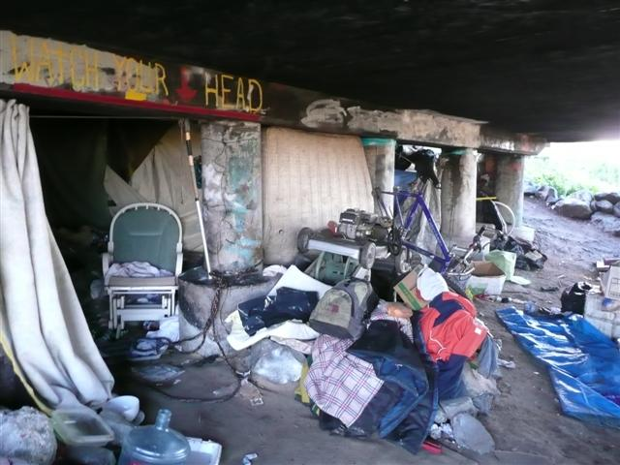

Crews cleaned up 15 encampments under bridge abutments along Walnut and Grayson Creeks manually and with boom trucks and other heavy equipment. Over seven dumpsters of debris were collected from these vital water-ways.

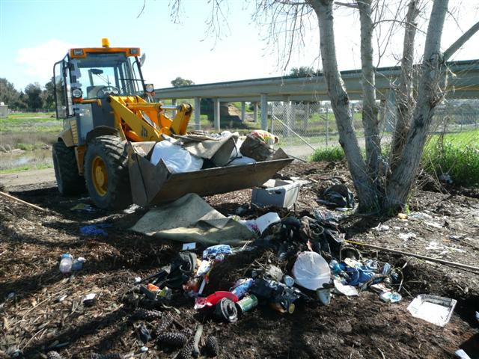
A follow-up presentation of the effort was shared with other municipalities during a joint presentation about the homeless encampment and trash abatement effort at the CCCWP’s Spring Municipal Maintenance Training Workshop held on April 24, 2009, at the Centre Concord. The Flood Control Crew Lead, Tony Medina, lead the presentation which was followed by lessons learned and added insight into the effort of organizing a trash/homeless encampment cleanup by staff from the CWP, Concord and Health Services Homeless Program. See page 8 of the spring 2009 County Clips Newsletter for an article about this impressive coordinated County Outreach Effort and Cleanup.

- CASQA Pre Conference Planning Workshop — Planning Practices and Tools to Address Emerging Water Quality Issues was attended by CWP on September 22, 2008. The workshop provided project designers planning tools for pollutant source control and stormwater treatment and BMPs for confronting emerging water quality issues in a sustainable manner.

- Stormwater Training for General Service Department Contractors — On June 24, 2009, the Custodial Division of the General Services Department (GSD) of Contra Costa County hosted an informational workshop on the proper disposal of wastewater following an illicit discharge incident by one of GSD’s contractors who was observed by sanitary district inspectors, pouring wash water down a parking lot storm drain at a County building in downtown Martinez. Clean Water BMPs and regulatory stormwater information was presented by Elisa Wilfong, Watershed Management Planning Specialist, with the CCCWP.

- Bay Friendly Landscaping Maintenance Training and Qualification Program — See discussion below.

Bay Friendly Landscaping Maintenance Training and Qualification Program

CWP advertised for this important training opportunity for municipal maintenance staff, the business community, and the public; we mailed out over 200 notices. The 2009 Bay Friendly Landscaping course was held this spring at the Antioch
Public Works Department from March 25 to May 9, 2009. The training was sponsored by the CCCWP and facilitated by Deborah Tillman from Alameda County, with 3-4 guest speakers in attendance at each session.

Four to five course flyers were mailed to 34 landscaping companies in Contra Costa County and a dozen or so announcements were sent to our Maintenance Division, Vegetative Management Crews, Special Districts and General Services, Grounds. CWP also stocked fliers at the front desk continuously in the month prior to the deadline for registration.

We were happy to be able to send one staff member from CWP, one from Flood Control Maintenance Division, and one from Vegetation Management to the seven week course. The class was also attended by four members of General Services, Grounds.

Topics covered included:
- Introduction to Bay Friendly Practices
- Soil Care and Plant Nutrition
- Water Management
- Waste Management
- Plant Choices and Gardening for Wildlife
- Integrated Pest Management
- Air Quality, Energy Conservation, Developing a Bay Friendly Site Analysis, Maintaining Bioswales, and Qualification Exam

The course mostly covered preventing stormwater pollution by eliminating the use of pesticides, using plants that require less water to minimize runoff and proper irrigation system design, installation, and maintenance. However, since the training was geared toward municipal staff with 30 of the 60 course slots reserved for municipal employees, it could also be included in the Municipal Maintenance portion of this Annual Report.

Storm Drain Marker Program

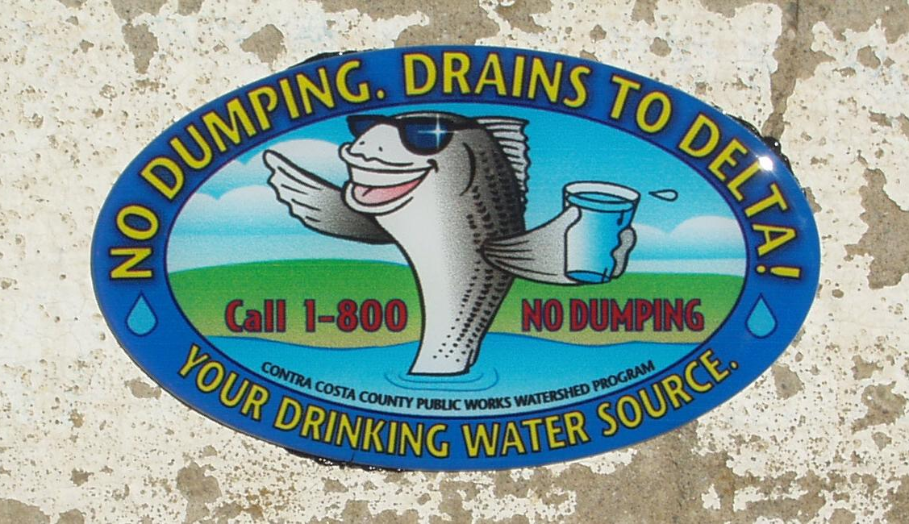
The CWP continued the successful Storm Marking Program during PY 2008/09 despite challenges related to quality of adhesive. The CWP’s student workers competently applied and mapped 2,368 storm drain markers during PY 2008/09. After this successful year of storm drain marking, a total of 4,845 markers have been applied.

The CWP completed marking of storm drains in the Discovery Bay, Danville, Stone Valley, Alamo, Pacheco, and Mountain View areas during PY 2008/09. These accomplishments add to already completed areas of Kensington,
Orinda, Bay Point, Concord, Rodeo, Crockett, Franklin Canyon, Bear Creek, Pinole Valley, Alhambra, Reliez Valley, Withers, Pinehurst, and Fish Ranch areas. During PY 2009/2010, the CWP will proceed with storm drain marking projects within the unincorporated portions of the West County areas, which will be discussed in next year’s Annual Report.

Several challenges were encountered related to the quality of adhesive purchased. The adhesive originally purchased failed to work after being stored over the winter. The adhesive became nearly impossible to use, prompting CWP to purchase a new adhesive that worked better than the original adhesive ever had. Therefore, we were able to return to our task of applying storm drain markers successfully.

The goal for the PY 2009/10 is to continue to mark as many storm drains as possible, while the CWP is staffed with student workers. The CWP student workers look forward to working on applying storm drain markers in areas such as North Richmond, Tara Hills, Tassajara, Marsh Creek, Morgan Territory, Deer Valley, Antioch, Rollingwood, McBryde, Bethel Island, Bollinger, and many others. Overall, it is hoped that the storm drain marking project will be completed during PY 2009/10.

CWP’s Revised Website

The CWP’s portion of the PWD’s website: http://www.cccounty.us/ index.aspx?NID=397 includes an important section about Pollution Prevention and Illicit Discharges/Illegal Dumping, which educates Contra Costa County citizens about them, their prevention, reporting and information about the types of illicit discharges various County Departments and State agencies respond to.

According to our NPDES permit, the CWP defines illicit discharges as any non-stormwater releases to the County’s storm drain system. Examples of common types of illicit discharges are provided and include soil from dirt piles staged along creek banks, leaves, and “green waste” raked into streets or spread along creek banks for weed suppression, incidental leaks of petroleum fluids from vehicles and equipment, accidental spills, such as paint and uninformed human behavior, such as hosing down driveways or washing out paint brushes into the gutter.

Our website educates the public about illegally dumped items and debris that can also find their way into the storm drain system and creeks just like any other litter. So that citizens become cognizant of the effects of dumping large objects that can lead to flooding and illegally disposing of hazardous waste and toxic substances, which can seep into the environment. The website also states that the CWP holds dischargers responsible for taking corrective action to cleanup their releases and responsible parties may be subject to fines, administrative penalties, and cost recovery.

One important function of the illicit discharge section of the website is to direct complainants to the appropriate agency in order to streamline notifications. Citizens can report stormwater violations in unincorporated areas of the County directly to CWP staff by calling (925) 313-2236 or by leaving a message on the 1-800-No-Dumping line managed by the CCCWP. The website encourages complainants to call this number for ease in reporting violations that may occur in different jurisdictions. Callers are informed they may also remain anonymous.

The website goes on to explain that CWP staff coordinates with Public Works Maintenance and other County Departments and Divisions to cleanup discharges as quickly and safely as possible when responsible parties are uncooperative or if the discharge is beyond the capabilities of the discharger. It also provides the breakdown of types of illicit discharges handled by CWP staff, other County Departments, and other government agencies in order to ensure appropriate response to discharges. For more detail about illicit discharge referrals at the County, go to the illicit Discharge Cleanup section of the website.

The CWP website also has a section under Pollution Prevention that summarizes how our citizens can Help Protect Your Watershed. It supplies tips called Best Management Practices (BMPs), which are common-sense precautions and simple everyday operating practices that prevent pollution at the source. BMPs at Home and at Work are provided to allow citizens to prevent illicit discharges and help protect our watersheds.

Earth Day Cleanup Event in Rodeo Creek

The CWP also sponsored the Contra Costa Resource Conservation District (on behalf of the Rodeo Watershed Vision Planning Group) in its 2009 Earth Day Cleanup of Rodeo Creek. The CWP donated supplies for 30 participants, including several bags of different-sized gloves and garbage bags to this effort, to remove trash from Rodeo Creek. It was also attended by our former Program Assistant, Jeri Johnson and her son, both residents of Rodeo.

Keep the Delta Clean Program
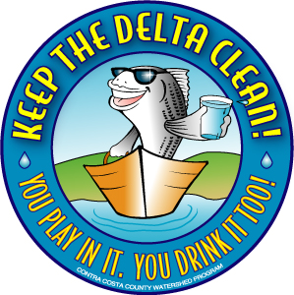
During PY 2008/09, Contra Costa County continued implementing Phase II of the KDC Program. The KDC Program was originally created (through a CALFED Proposition 13 Drinking Water Grant) to provide new pollution prevention infrastructure at marinas and to provide education for boaters intended to promote environmentally sound practices. A crucial aspect of the KDC Program is the formation of networks and lines of communication between various stakeholders in the Sacramento-San Joaquin Delta; staff worked with pilot marinas to ensure lasting relationships between them and the County.

As discussed in the PY 2005/06 Annual Report, in 2006 Contra Costa County applied for a grant to expand the KDC Program to a region-wide effort and was awarded $1.6 million in Proposition 40 funds from the State Water Resources Control Board (SWRCB). An agreement was executed between the County and the SWRCB on January 11, 2007. Since that time, the County has formed a regional partnership with other municipalities in the Delta region, including the City of Stockton and the City of Sacramento; and San Joaquin, Solano, and Yolo Counties. (Due to staffing constraints, Sacramento County has since opted out of this program; however, Sacramento County remains interested in working with the KDC program in the future, and continues to be involved at a less formal level.)

Through this regional effort, “Phase II” of the KDC Program, over 10,000 boater kits have been distributed; pollution prevention infrastructure has been installed at marinas throughout the Delta; a clean boating website has been developed; marina operators have been trained in the proper handling of hazardous materials they may encounter at their marinas; stakeholder networking has continued through the Delta Chapter of the California Clean Boating Network (CCBN) (established through Phase I of the KDC); water has been sampled from the Delta; boaters have been surveyed about their boating habits for analysis and incorporation into a conceptual model for use in assisting future pollution prevention efforts in the Delta and elsewhere; and “dock walkers” — boaters who have been enlisted to go out on the water to educate other boaters about environmentally sound boating practices — have been trained.

Remaining deliverables are the distribution of the remaining boater kits and several reports (water quality, boater survey data, and a final report). In December 2008, all projects receiving funding from Proposition 40 monies were frozen. The freeze is still in place as of this writing. CWP believes KDC is a very valuable program and so has continued to implement it, albeit at a reduced level. Focus has been on sending boater kits to volunteers for distribution to reduce staff time. Fortunately most work has been completed on the KDC Program; however, reporting remains incomplete. Department of Boating and Waterways has agreed to fund the completion of a study based on the boater surveys received, but a report on water quality to be completed by San Francisco Estuary Institute remains on hold until the freeze has ended.

Modifications:

None.

Permit Year 2009/10 Goals:

- Continue to work with municipalities bordering our flood control channels at pollutant source control and combating illicit discharges.

- Work with GIS Division and their new mapping software application to map this and previous Permit Years’ illicit discharge data in order to view which locations are hotspots for discharges and look for trends in the types of discharges.

- Continue to participate in the development of a feasible, flexible, cost-effective MRP that will include water quality objectives and trash capture requirements that are attainable and will result in noticeable positive improvements to our watersheds.

- Continue to maintain existing storm drain markers and replace missing ones as needed.

- Continue to work with Flood Control and other departments to identify dumping hotspots and target illicit discharge problem areas in preparation for the MRP.

- Use this Permit Year’s illicit discharge data to target problem areas in future outreach.

- Prepare for MRP’s proposed trash assessment requirement and assign responsibilities to in-house divisions like CWP, Maintenance, and Construction; and other departments, such as the Department of Conservation and Development’s Watershed Forum or outside contractors/nonprofits, such as the Watershed Project.

- Work with CCCWP to develop an Enforcement Response Plan.

- Create more enforcement “tools” for dealing with chronic and recalcitrant dischargers, such as illegal dumpers and restaurants that continue to leave their dumpsters open, such as a Notice of Violation for Stormwater Discharges that will allow CWP to cite for the $ cited in our Government Ordinance in order to get the attention of the few chronic dischargers we’ve been dealing with.

- Create a Clean Water Violation Notice that is more generic than the current version for unpermitted Construction/landscaping activity, and so will be able to be used for any type of illicit discharge.
Illicit Discharge Control Activities – quantitative results

Description | Industrial Areas | Commercial Areas | Residential Areas | Total
Field Screenings

Total number of field screening areas identified within the Agency’s entire drainage area |  |  |  | 21
Total number of field screening areas identified in the Annual Illicit Discharge Control Plan |  |  |  | 9
Number of priority field screening areas inspected |  |  |  | 2
Number of medium and low priority areas inspected. |  |  |  | 2
Number of illicit connections/illegal discharges eliminated |  |  |  | 45
Number of incidents that involved removal of the following materials

Construction materials/debris | 1 | 4 | 13 | 18
Sewage | 0 | 5 | 9 | 14
Food wastes | 0 | 2 | 0 | 2
Automotive fluids | 5 | 6 | 26 | 37
Yard wastes | 0 | 0 | 7 | 7
Other | 4 | 4 | 9 | 17
Other: Grey Water | 2 | 7 | 8 | 17
Other: Marine Related | 1 | 0 | 0 | 1
Enforcement Activities

Number of Enforcement Actions Taken

Written corrective measures | 1 | 11 | 25 | 37
Notices to comply | 0 | 1 | 2 | 3
Stop work orders | 0 | 0 | 0 | 0
Notices of violation | 0 | 9 | 25 | 34
Fines | 0 | 0 | 0 | 0
Other | 1 | 1 | 0 | 2
Number of enforcement referrals (e.g., to code enforcement, City or District Attorney, other agencies, Regional Board, etc.) | 0 | 5 | 14 | 19
Education/Outreach Activities

Number of illicit discharge control education materials distributed |  |  |  | 14
Number of employees attending illicit discharge control training workshops |  |  |  | 6

