Implementing MRP Provision C.3 Requirements for Land Development
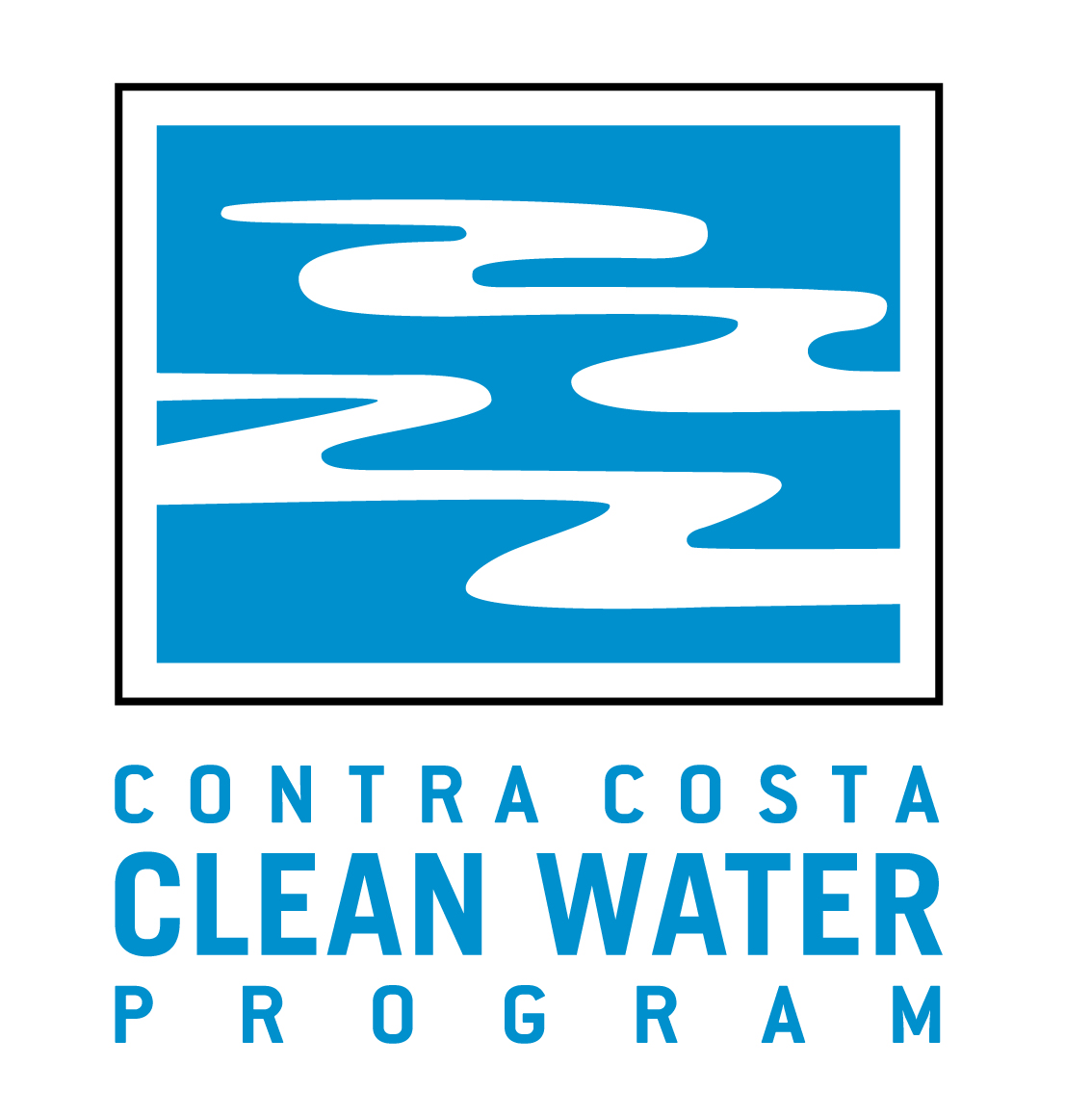

A Workshop on C.3 Basics for Municipal Staff

Presenter: Dan Cloak, P.E., Dan Cloak Environmental Consulting

Tuesday, June 11, 2013 – 8:30 AM to 12:30 PM
Shadelands Art Center, 111 N. Wiget Lane, Walnut Creek

8:30 – 8:40 | Check-In and Continental Breakfast
8:40 – 8:50 | Greeting and Introductions
8:50 – 9:05 | Overview  Regulatory History, C.3 and Development Review, Tools and Resources
9:05 – 9:15 | Applicability of the C.3 Requirements
9:15 – 10:00 | LID Conceptual Design  The Why and How of LID, Analyzing a Project for LID, The Five LID Strategies, Screening the Feasibility of Harvest and Use.
10:00 – 10:10 | Break
10:10 – 10:40 | Delineating Drainage Management Areas
10:40 – 11:30 | Reviewing Stormwater Control Plans  Special Projects, Drainage Design Calculations, Source Controls,  Small Projects
11:30 – 11:40 | Break
11:40 – 12:00 | Bioretention Design and Construction  Special Projects, Drainage Design Calculations, Source Controls
12:00 – 12:15 | Operation and Maintenance Verification
12:15 – 12:30 | Discussion
12:30 | Adjourn

