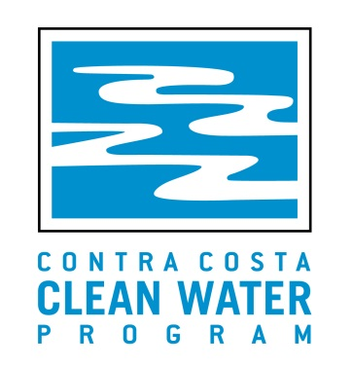
Maintaining Greek Infrastructure/Bioretention Facilities
Thursday, March 21, 2019
8:00 am – Noon
3rd Floor Conference Room; Walnut Creek City Hall
1666 North Main St.; Walnut Creek, CA

7:30 am Registration and Continental Breakfast

8:00 am Welcome and Introductions
Beth Baldwin, Contra Costa Clean Water Program

8:10 am What is Green Infrastructure?
Dan Cloak, P.E., Dan Cloak Environmental Consulting
Megan Stromberg, Megan W. Stromberg Consulting

9:15 am Preparation for Maintenance
Megan Stromberg

9:30 am Trash, Debris, Leaf Litter, Sediment Removal
Megan Stromberg

9:45 am Break

10:00 am Biotreatment Soil Mix and Mulch
Megan Stromberg

10:15 am Plants and Irrigation
Megan Stromberg

10:45 am Wrap Up and Evaluations
Beth Baldwin, Contra Costa Clean Water Program

11:00 am Walking Tour of Green Infrastructure Facilities

12:00 am Adjourn

Request for Feedback on Maintaining Greek Infrastructure/Bioretention Facilities Workshop
March 21, 2019

- What were the most useful things you learned or discussed at the workshop?

- What did you think of the format, including the time used for discussion of current topics?

- What could have been done better? Is there a topic you wanted to hear more about?

- Any other comments?

- What is your primary job function?

_____ Grounds/Parks/Landscape Crew

_____ Maintenance

_____ Stormwater Coordinator

_____ Other:___________________________________________________

