Field Walk Notes, Walnut Creek Library 3/21/19
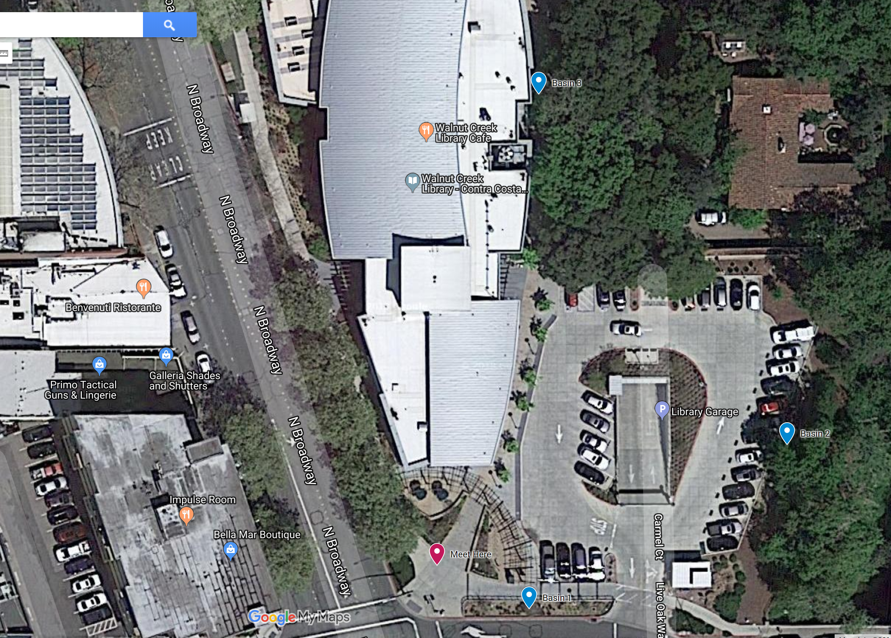

Station 1 – Parking Lot on Lincoln Ave (DAN)
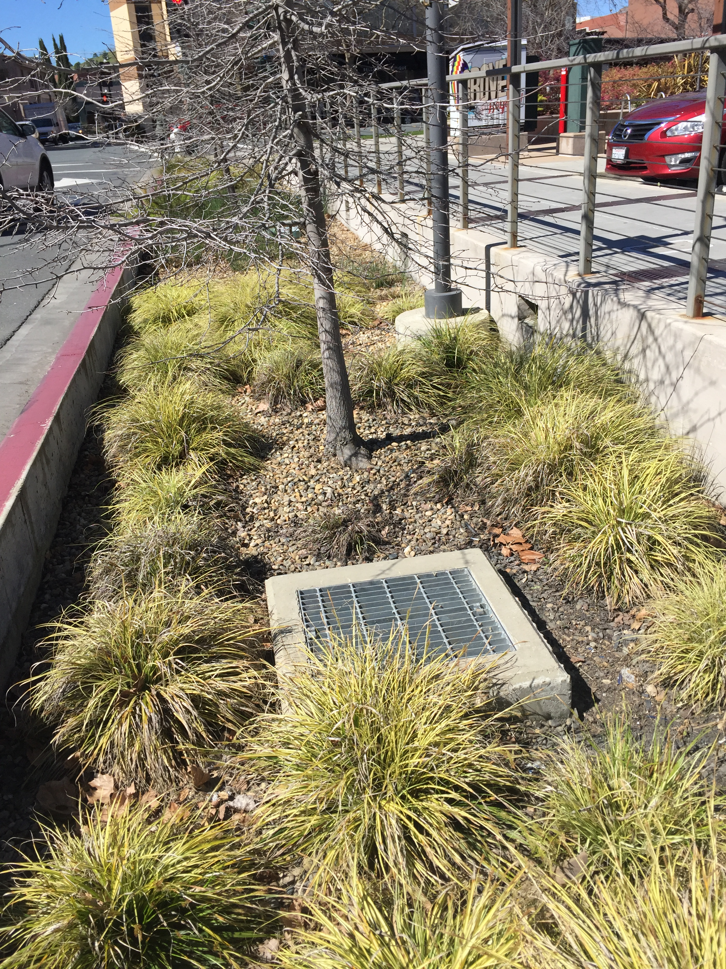
- Is this bioretention or flow through? (bioretention, probably)
- Point out or Ask people to point out the parts:
  - Inlets (both from lot and into basin)
  - scour protection,
  - Overflow,
  - cleanout,
  - grasses,
  - trees,
  - rock mulch,
  - spray irrigation, bubblers for trees
- What would you do here to maintain?
  - Debris in inlet at west corner of parking lot
  - Trash?
  - Plants (sedges) look generally good. These can be cut back every few years but not required. Can be divided and replanted if bare areas.
  - Some plants not thriving – why? Investigate if irrigation is blocked by healthier plants. If only one plant is not doing well, its ok.
- Trees look healthy, yay
- Direct people to station 2 (East edge of parking lot by creek)

Station 2 – East edge pf Parking Lot by Creek (MEGAN)
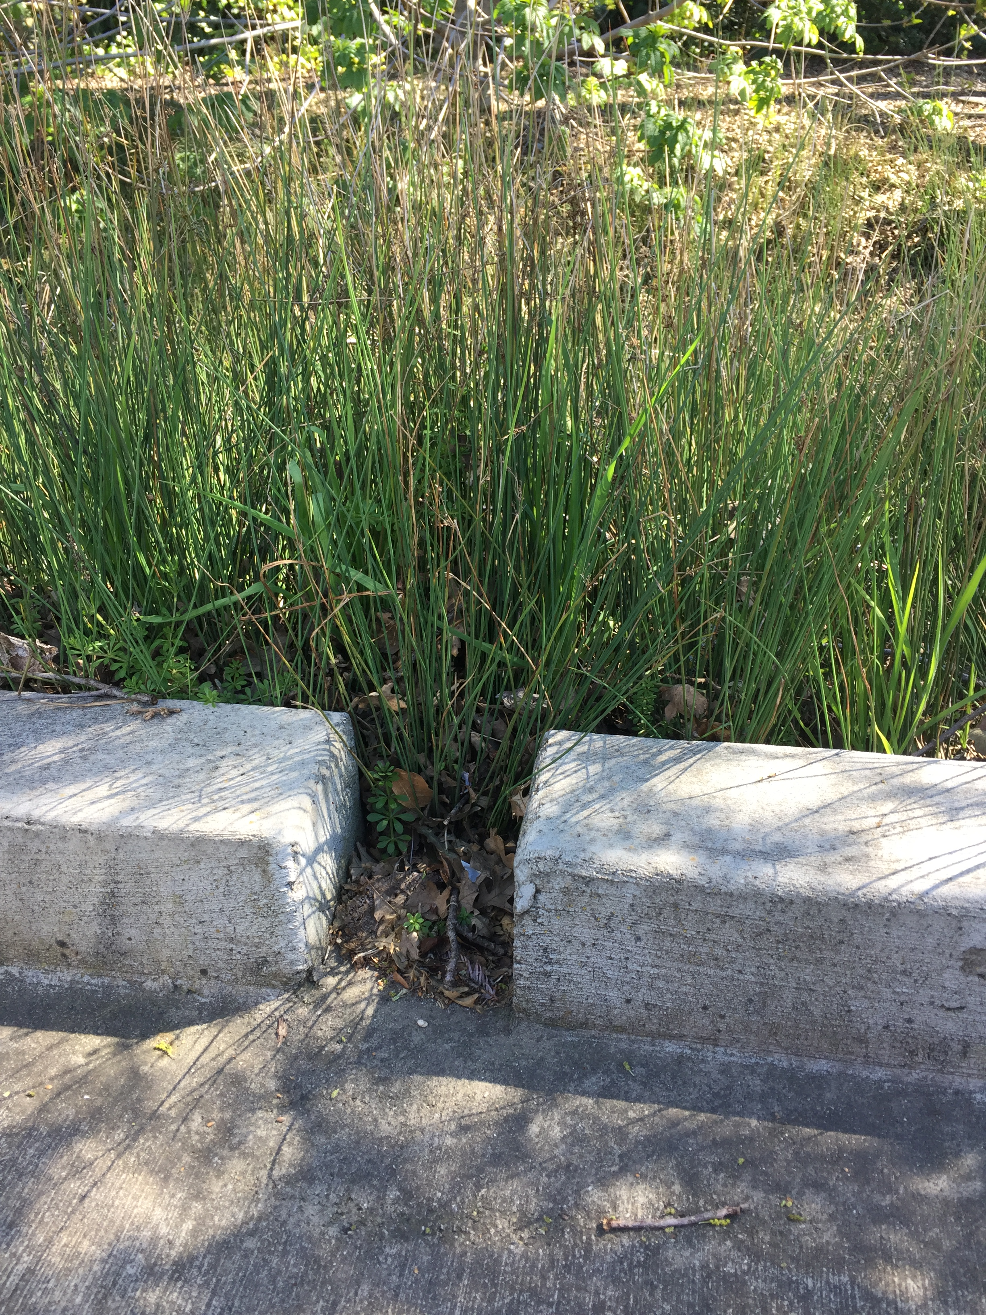
- Is this bioretention or flow through? (bioretention)
- Point out or Ask people to point out the parts:
  - Inlets
  - Overflow,
  - cleanout,
  - grasses,
  - rock mulch,
  - spray irrigation
- What would you do here to maintain?
  - Weeds at the south end – optional to pull by hand, they are not impeding function
  - Several inlets are blocked by healthy juncus. These can be dug up and relocated. Then add rock mulch at the inlets making sure to leave a 1-2” drop right at the inlet to allow for sediment to accumulate.
  - Trash
  - The inlet at the north end is not blocked but there is evidence of erosion. See headcut coming up from bottom of basin and accumulation of sediment in bottom of basin. Overtime this area of basin may clog. Consider removing top 2-3” and replacing with biotreatment soil mix and rock mulch.
  - Cleanout getting buried by gravel above
  - Otherwise plants very healthy, no need to cut back
  - Overflow has a few leaves but nothing major
  - Leaf litter is ok to leave
- Direct people to station 3 – next to building
- Mention people can walk around entire building to see other bioretention

Station 3 – Planter next to building (RINTA)
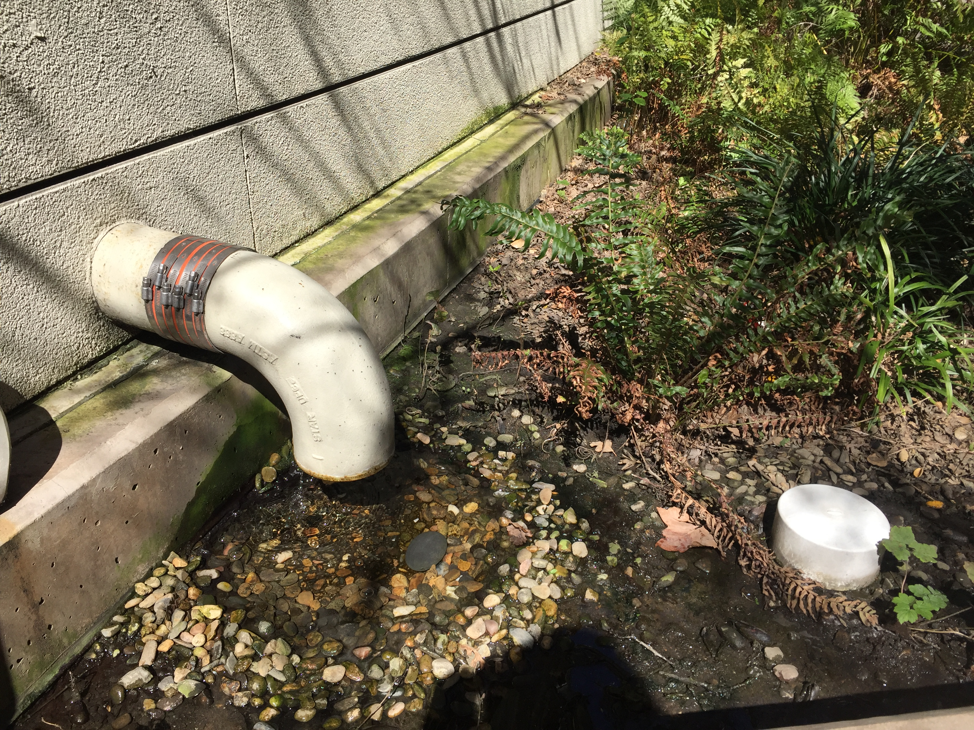
- Is this bioretention or flow through planter? (flow through planter)
- Point out or ask people to point out the parts:
  - Inlets
  - Overflow,
  - cleanout,
  - plants & trees
  - rock mulch,
  - irrigation
  - This basin receives air conditioning effluent
  - Splash bocks are concrete
- What would you do here to maintain?
  - Plants are generally healthy, area of rubus is somewhat thin but could be time of year
  - Very healthy Japanese Maples are probably due to the A/C effluent providing extra water
  - Is this basin on a separate valve from other irrigation? Consider limiting the watering schedule to save water unless all the flow-through planters are on same valve.
  - Trash
  - Generally, flow-through planters have less input of sediment and trash
  - This basin is in the shade which is a big benefit to the plants because of fast draining soils. Flow-through planters on south facing buildings get hammered with direct and reflective light and often become sand pits. Try very drought resistant plants in those types of basins.
- Appears that there is also fire sprinkler flushing effluent into one planter
- Mention Bioretention on the opposite side of building (along Broadway) gets more sun. After field walk is done, people can walk past it on their own to compare and contrast the plant health. Wouldn’t it be nice if the air-conditioning & fire effluent happened on the sunny side? Designers…
- Direct people to Basin 1 (Parking lot on Lincoln Ave)

