Model Text for Green Infrastructure Staff Report – Draft 11 March 2016

The [City, Town, County] is one of 76 local agencies (Permittees) subject to the California Regional Water Quality Control Board, San Francisco Bay Region’s Municipal Regional Stormwater NPDES Permit (MRP). The MRP was adopted in 2009 (MRP 1.0) and reissued in November 2015 (MRP 2.0).
In MRP 2.0, Provisions C.11 and C.12 require the Permittees to reduce discharges of Mercury and PCBs, respectively.
A portion of these load reductions must be achieved by retrofitting existing impervious surfaces with Green Infrastructure.
MRP 2.0 defines Green Infrastructure:
Infrastructure that uses vegetation, soils, and natural processes to manage water and create healthier urban environments. At the scale of a city or county, green infrastructure refers to the patchwork of natural areas that provides habitat, flood protection, cleaner air, and cleaner water. At the scale of a neighborhood or site, green infrastructure refers to stormwater management systems that mimic nature by soaking up and storing water.
Contra Costa Permittees, collectively, must implement Green Infrastructure to reduce—from 2014 levels—mercury loading by 9 grams/year and PCB loading by 23 grams/year by 2020. Permittees must plan for substantially larger reductions in the following decades.
Green Infrastructure on both public and private land can serve to achieve these load reduction requirements. Implementation on private land is achieved by implementing stormwater requirements for new development and redevelopment (Provision C.3.a. through Provision C.3.i.), which were carried forward, largely unchanged, from MRP 1.0.
In MRP 2.0, Provision C.3.j. includes requirements for Green Infrastructure planning and implementation. Provision C.3.j. has two main elements to be implemented by municipalities:
- Preparation of a Green Infrastructure Plan for the inclusion of Low Impact Development (LID) drainage design into storm drain infrastructure, including streets, roads, storm drains, etc.
- Early implementation of Green Infrastructure Projects

Green Infrastructure Plan
The Green Infrastructure Plan requirements and deadlines are:
- Prepare a framework or workplan to be approved by the [Board or Council] by June 30, 2017.
- Submit a Green Infrastructure Plan with the 2019 Annual Report.
The Green Infrastructure Plans are intended to describe how each jurisdiction will, in the coming decades, shift their impervious surfaces and storm drain infrastructure from gray, or conventional, storm drain infrastructure where runoff flows directly in to the storm drain and then to creeks and the Bay, to a more resilient, sustainable system that slows runoff by dispersing it to vegetated areas, harvests and uses runoff, promotes infiltration and evapotranspiration, and uses bioretention to detain, retain, and treat stormwater.
Among the specific requirements is to summarize other planning documents that are updated or modified to incorporate green infrastructure requirements. These may include:
- General Plans
- Specific Plans
- Complete Streets Plans
- Active Transportation Plans
- Storm Drain Master Plans
- Pavement Work Pans
- Urban Forestry Plans
or other plans that may affect the future alignment, configuration or design of impervious surfaces such as streets, parking lots, sidewalks, and roofs.
Staff is coordinating with other Contra Costa municipalities, through the Contra Costa Clean Water Program (CCCWP), to develop a model framework or workplan. This model will be adapted to meet the [City’s, Town’s, County’s] needs and brought to the [Council or Board] during FY 2016-2017.

Early Implementation (No Missed Opportunities)
Provision C.3.j.ii. requires that each Permittee review current infrastructure (capital improvement) projects, prepare a list of infrastructure projects planned for implementation during the permit term that have potential for green infrastructure measures, and submit the list with each Annual Report, including:
… a summary of how each public infrastructure project with green infrastructure potential will include green infrastructure measures to the maximum extent practical during the permit term. For any public infrastructure project where implementation of green infrastructure measures is not practicable, submit a brief description for the project and the reasons green infrastructure measures were impracticable to implement.
Staff is coordinating with other Contra Costa municipalities, through the Contra Costa Clean Water Program (CCCWP), to develop model guidance for reviewing capital improvement programs and projects, identifying green infrastructure potential, advancing planning and design of potential green infrastructure features, and documenting decisions regarding implementation of green infrastructure. The model guidance will be adapted to meet the [City’s, Town’s, County’s] needs and will be implemented by the [Public Works, Engineering] Department during the current fiscal year.

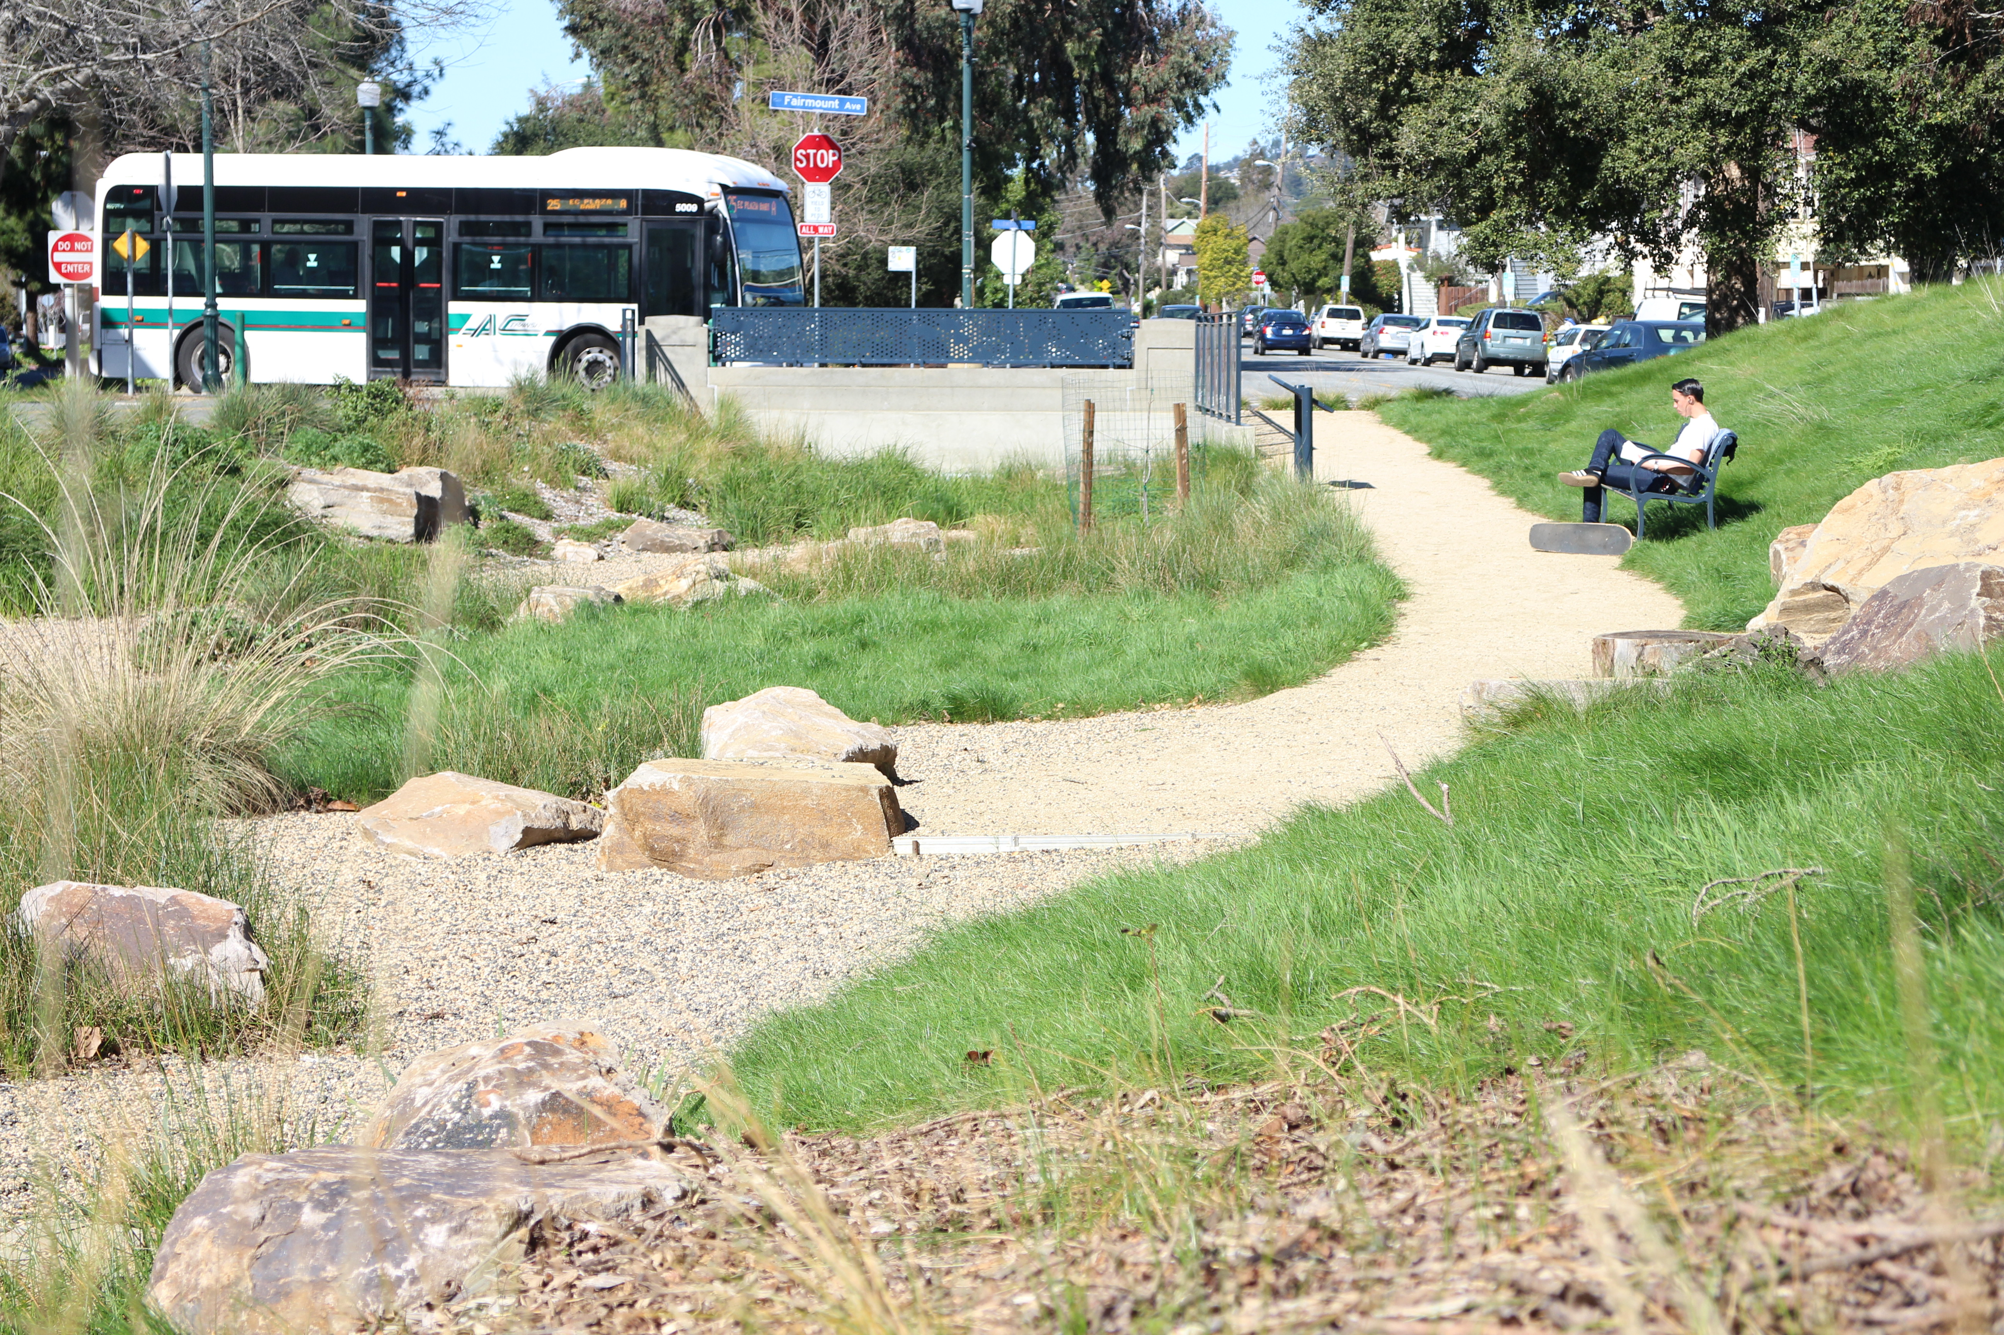
Green Infrastructure: Bioretention facility with active and passive landscape uses (El Cerrito)
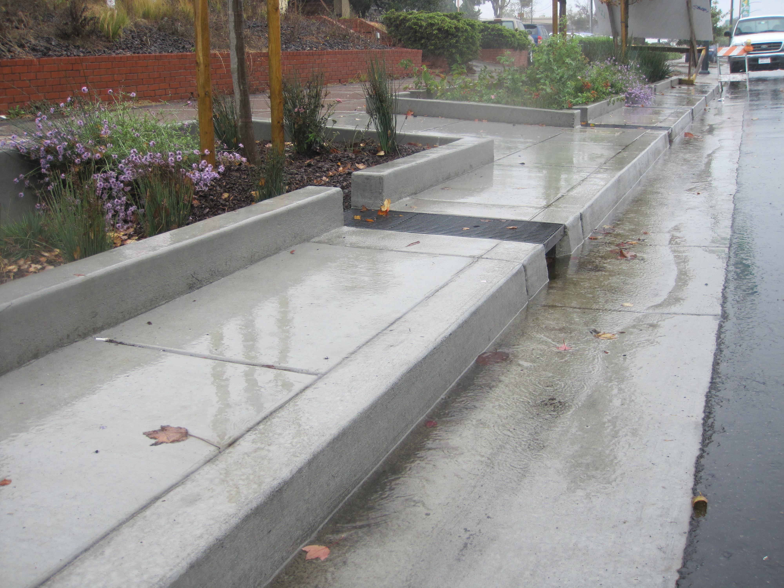
Green Infrastructure: Bioretention facilities treating street runoff.

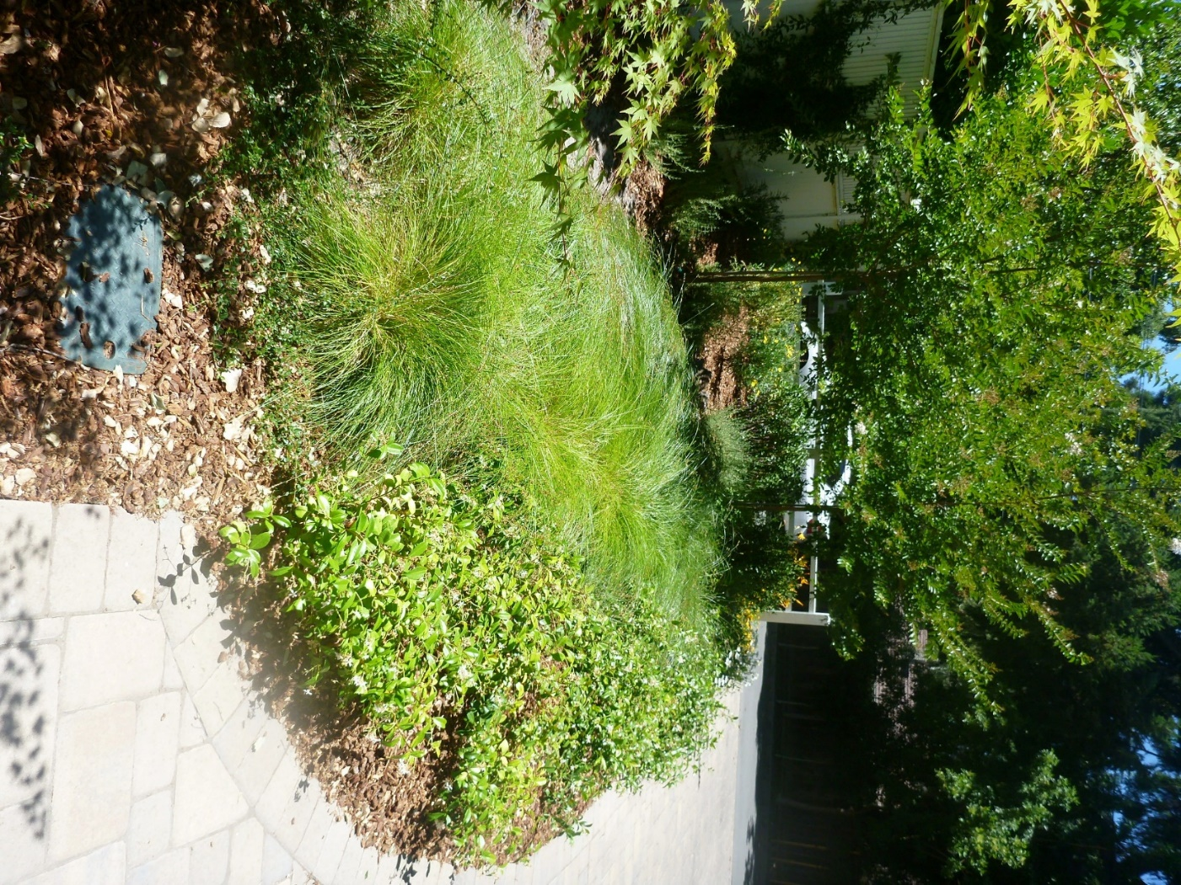
Green Infrastructure: Bioretention treating runoff from residences and a private street
(Contra Costa County)

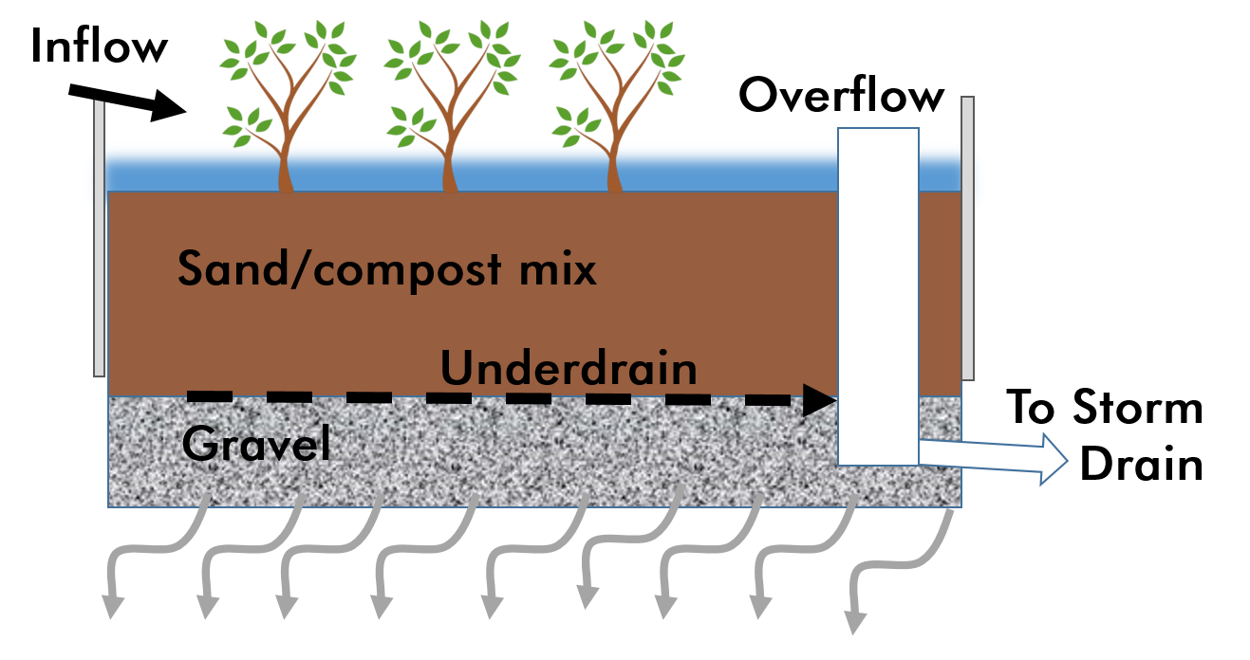
Green Infrastructure: Illustrative cross-section of Bioretention Facility

