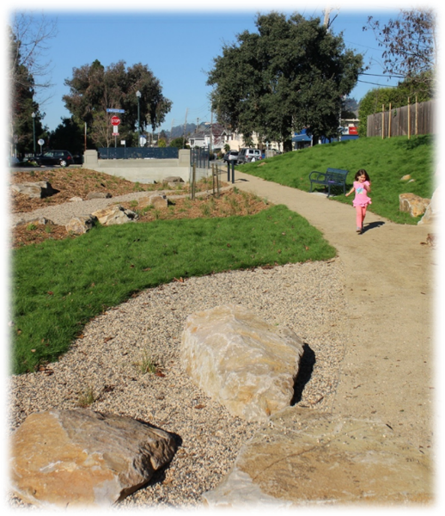
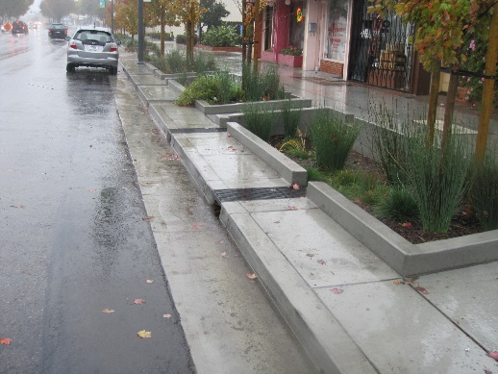
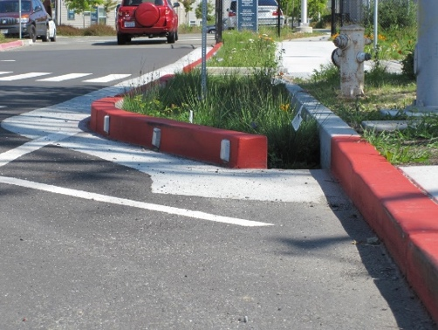
Green
Infrastructure
Plan
DRAFT TEMPLATE—APRIL 2018
Contents
Acronyms iii
1 Introduction and Overview 1
1.1 Regulatory Mandate 1
1.2 Objectives and Vision 3
1.3 Plan Context and Elements 3
2 Green Infrastructure Targets 6
2.1 Private Development Projections 6
2.2 Targets for Public Projects 7
2.3 Projected Load Reductions [Placeholder] 8
3 Public Project Identification, Prioritization, and Mapping 9
3.1 Tools for Project Identification and Prioritization 9
3.2 Maps and Project Lists 9
4 Early Implementation Projects 10
4.1 Review of Capital Improvement Projects 10
4.2 List of Projects Identified 10
4.3 Workplan for Completion 10
5 Tracking and Mapping Public and Private Projects Over Time 11
5.1 Tools and Process 11
5.2 Results 11
6 Design Guidelines and Specifications 12
6.1 Guidelines for Streetscape and Project Design 12
6.2 Specifications and Typical Design Details 12
6.3 Sizing Requirements 12
7 Funding Options 13
7.1 Funding Strategies Developed Regionally 13
7.2 Local Funding Strategies 13
8 Adaptive Management 14
8.1 Process for Plan Updates 14
8.2 Pursuing Future Funding Sources 14
8.3 Alternative Compliance and Credit Trading Investigations 14

Tables
Table x. Documents Updated to Align with this Green Infrastructure Plan 4
Table x. Estimates of Impervious Surface to Be Retrofit via Private Development 6
Table x. Estimates of Impervious Surface to Be Retrofit via Public Projects 6
Table x. Capital Improvement Projects with Green Infrastructure Potential (identified 2015-2019) 9

Figures
Figure x. Sample Figure 7

Appendices (links)
- Public Project Lists and Maps
- Green Infrastructure Guidelines for Streetscape and Project Design
- Green Infrastructure Specifications and Typical Design Details
- Sizing Requirements for Green Infrastructure Facilities

Acronyms
ABAG | Association of Bay Area Governments
BASMAA | Bay Area Stormwater Management Agencies Association
CCCWP | Contra Costa Clean Water Program
CCW SWRP | Contra Costa Watersheds Stormwater Resource Plan
GI | Green Infrastructure
GIS | Geographic Information System
IRWMP | Integrated Regional Water Management Plan
MRP | Municipal Regional Stormwater Permit
MTC | Metropolitan Transportation Commission
NPDES | National Pollutant Discharge Elimination System
PCBs | Polychlorinated Biphenyls
TMDL | Total Maximum Daily Load

Introduction and Overview

Regulatory Mandate
“Provisions C.11 and C.12 in the MRP require Contra Costa Permittees (Contra Costa County and its 19 cities and towns) to reduce estimated PCBs loading by 23 grams/year and estimated mercury loading by 9 grams/ year using Green Infrastructure
by June 30, 2020.”
The [Permittee] is one of 76 local government entities subject to the requirements of the California Regional Water Quality Control Board for the San Francisco Bay Region’s (RWQCB’s) Municipal Regional Stormwater Permit (MRP). The MRP was last reissued in November 2015. The MRP mandates implementation of a comprehensive program of stormwater control measures and actions designed to limit contributions of urban runoff pollutants to San Francisco Bay.
MRP Provision C.3.j.i. requires [Permittee} to prepare a Green Infrastructure Plan, to be submitted with its Annual Report to the RWQCB due September 30, 2019.
Green Infrastructure refers to the construction and retrofit of storm drainage to reduce runoff volumes, disperse runoff to vegetated areas, harvest and use runoff where feasible, promote infiltration and evapotranspiration, and use bioretention and other natural systems to detain and treat runoff before it reaches our creeks and Bay. Green infrastructure facilities include, but are not limited to, pervious pavement, infiltration basins, bioretention facilities or “raingardens”, green roofs, and rainwater harvesting systems. Green infrastructure can be incorporated into construction on new and previously developed parcels, as well as new and rebuilt streets, roads, and other infrastructure within the public right-of-way.
Water quality in San Francisco Bay is impaired by mercury and by polychlorinated biphenyls (PCBs). Sources of these pollutants include urban stormwater. By reducing and treating stormwater flows, green infrastructure reduces the quantity of these pollutants entering the Bay and will hasten the Bay’s recovery.
Provisions C.11 and C.12 in the MRP require Contra Costa Permittees (Contra Costa County and its 19 cities and towns) to reduce estimated PCBs loading by 23 grams/year and estimated mercury loading by 9 grams/year using green infrastructure by June 30, 2020. Regionally, Permittees must also project the load reductions achieved via Green Infrastructure by 2020, 2030, and 2040, showing that collectively, reductions will amount to 3 kg/year PCBs and 10 kg/year mercury by 2040.

Further Background on Mercury and PCBs in San Francisco Bay
The MRP pollutant-load reduction requirements are driven by Total Maximum Daily Load (TMDL) requirements adopted by the RWQCB for mercury (Resolution No. R2-2004-0082 and R2-2005-0060) and PCBs (Resolution No. R2-2008-0012). Each TMDL allocates allowable annual loads to San Francisco Bay (a Waste Load Allocation, or WLA) from identified sources, including from urban stormwater.
The mercury TMDL addresses two water quality objectives. The first, established to protect people who consume Bay fish, applies to fish large enough to be consumed by humans. The objective is 0.2 milligrams (mg) of mercury per kilogram (kg) of fish tissue (average wet weight concentration measured in the muscle tissue of fish large enough to be consumed by humans). The second objective, established to protect aquatic organisms and wildlife, applies to small fish (3-5 centimeters in length) commonly consumed by the California least tern, an endangered species. This objective is 0.03 mg mercury per kg fish (average wet weight concentration). To achieve the human health and wildlife fish tissue and bird egg monitoring targets and to attain water quality standards, the Bay-wide suspended sediment mercury concentration target is 0.2 mg mercury per kg dry sediment.
A roughly 50% decrease in sediment, fish tissue, and bird egg mercury concentrations is necessary for the Bay to meet water quality standards. Reductions in sediment mercury concentrations are assumed to result in a proportional reduction in the total amount of mercury in the system, which will result in the achievement of target fish tissue and bird egg concentrations.
The PCBs TMDL was developed based on a fish tissue target of 10 nanograms (ng) of PCBs per gram (g) of fish tissue. This target is based on a cancer risk of one case per an exposed population of 100,000 for the 95th percentile San Francisco Bay Area sport and subsistence fisher consumer (32 g fish per day). A food web model was developed by San Francisco Estuary Institute (SFEI) to identify the sediment target concentration that would yield the fish tissue target; this sediment target was found to be 1 microgram (µg) of PCBs per kg of sediment.
Twenty percent of the estimated allowable PCB external load was allocated to urban stormwater runoff. The Bay Area-wide WLA for PCBs for urban stormwater is 2 kg/yr by 2030. This value was developed based on applying the required sediment concentration (1 µg/kg) to the estimated annual sediment load discharged from local tributaries.

Objectives and Vision
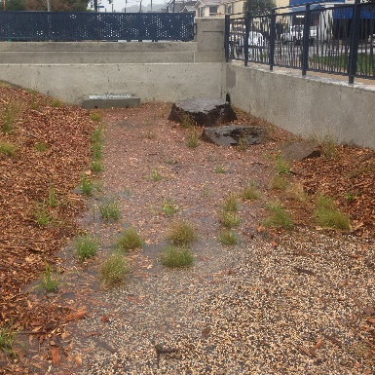
This Plan will guide a shift from conventional “collect and convey” storm drain infrastructure to more resilient, sustainable stormwater management systems that reduce runoff volumes, disperse runoff to vegetated areas, harvest and use runoff where feasible, promote infiltration and evapotranspiration, and use natural processes to detain and treat runoff. Green infrastructure features and facilities include, but are not limited to, pervious pavement, infiltration basins, and bioretention facilities (“rain gardens”), green roofs, and rainwater harvesting systems.
As required by Provisions C.3.a. through C.3.i. in the MRP, these “Low Impact Development” practices are currently implemented on land development projects in the [Permittee]. Specific methods and design criteria are spelled out in the Contra Costa Clean Water Program’s (CCCWP’s) Stormwater C.3 Guidebook, which the [Permittee] has referenced in [ordinance title or municipal code section].
This Plan details how similar methods will be incorporated to retrofit existing storm drainage infrastructure using green infrastructure facilities constructed on public and private parcels and within the public right-of-way.
- Green infrastructure facilities previously constructed by the Permittee

Plan Context and Elements

Planning Context
- Municipal geography
- Demographics
- Economic and Social Trends
- Development and Redevelopment Trends
- Commitment and Actions for Sustainability
- Staffing and Scope of Sustainability Programs
- CEQA

Watersheds and Storm Drainage Infrastructure
- Watersheds and Watershed Characteristics and Challenges
- Major Drainages and Major Drainage Characteristics and Challenges
- Storm Sewer System
- Storm Sewer Challenges (Pertinent to GI)
- Flood Zones
- Flood Control Facilities
- Flood Control Development Policies
- Storm Sewer Opportunities (Pertinent to GI)
- Recent and Planned Drainage Improvements
- Funding for Maintenance and for Capital Improvements

Related Regional and Countywide Plans and Planning Documents
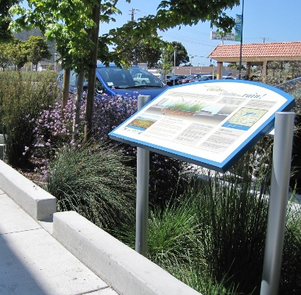
This Plan has been coordinated with the following regional stormwater documents:
- The Contra Costa Watersheds Stormwater Resource Plan (CCW SWRP). The CCW SWRP was funded by State Water Resources Control Board under a Proposition 1 Grant, with matching contributions provided by Contra Costa municipalities individually and collectively through the Contra Costa Clean Water Program (CCCWP). The CCW SWRP identified and prioritized potential multi-benefit stormwater management projects, including green infrastructure projects in watersheds and jurisdictions throughout Contra Costa County. Projects identified within the CCW SWRP are eligible to apply for future state funding. Many of the projects included in this Plan were drawn from the CCW SWRP project opportunity lists.
- The Contra Costa Countywide Reasonable Assurance Analysis (RAA). The RAA for Green Infrastructure is being prepared by Contra Costa municipalities collectively through the CCCWP and is consistent with guidance prepared by the Bay Area Stormwater Management Agencies Association (BASMAA). The RAA for Green Infrastructure uses a water quality model coupled with continuous simulation hydrologic output to estimate baseline loadings of pollutants and the reductions that might be achieved through green infrastructure implementation in 2020, 2030, and 2040 under various scenarios, which include implementation of projects identified in this Plan. Results pertinent to green infrastructure planning and implementation are discussed in Section 2 of this Plan.
- Further discussion of the relationship of the Green Infrastructure Plan to Additional Regional and Countywide Plans

Related Local Planning Documents
- Provision C.3.j.i.(2)(h); TRT Item 16

Green infrastructure can be integrated into a wide diversity of public and private projects. Public projects can incorporate green infrastructure in streets, parks, schools, and other civic properties. In order to ensure that green infrastructure is considered and supported in the range of planning and design processes for these projects, [Permittee] has reviewed and/or updated the following planning documents to appropriately incorporate green infrastructure requirements:
Table x. Documents Updated to Align with this Green Infrastructure Plan
Document | Summary of Updates | Completion Date
General Plan
Specific Plan
Urban Greening Plan
Sustainable Communities Strategy
Complete Streets Plan
Storm Drainage Master Plan
Standard Details and Specifications
- Discussion of significant updates and how these updates have or will successfully integrate green infrastructure into local policies.
- Workplan identifying how the Permittee will ensure that green infrastructure and Low Impact Development are appropriately included in future plans.

Outreach and Education
- Provision C.3.j.i.(4); TRT Item 17

The [Permittee’s] Green Infrastructure Plan development process engaged a wide variety of stakeholders, including both government staff and community members who will live, work, and play near future green infrastructure projects. The [Permittee] also intends to engage relevant government staff and community members as projects move forward towards design and implementation.

- Interdepartmental coordination process leading to adoption of the Green Infrastructure Plan
- Public process leading to adoption of the Green Infrastructure Plan
- Public process associated with initiation and planning of green infrastructure projects (typical, and/or examples)
- General outreach and targeted outreach to and training for professionals involved in green infrastructure planning and design
- Staff training on green infrastructure planning and implementation, including planning, engineering, public works maintenance, finance, fire/life safety, and management staff
- Staff participation in regional processes to promote Green Infrastructure (such as the regional roundtable and design charrette).

Policies, Ordinances, and Legal Mechanisms
- Provisions C.3.j.i.(3) and C.3.j.i.(5)(c); TRT Item 15
- Summarize resolutions, ordinances, and policies adopted in connection with the Green Infrastructure Plan
- Include copies in an Appendix.

Green Infrastructure Targets
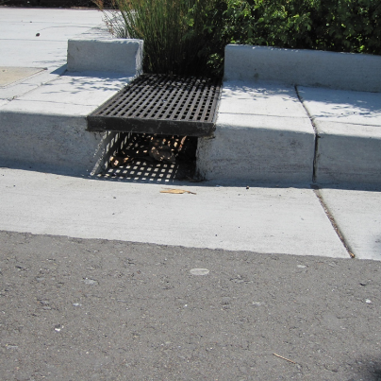
Provisions C.11 and C.12 in the MRP require Contra Costa Permittees (Contra Costa County and its 19 cities and towns) to reduce estimated PCBs loading by 23 grams/year and estimated mercury loading by 9 grams/year using green infrastructure by June 30, 2020. Regionally, Permittees must also project the load reductions achieved via green infrastructure by 2020, 2030, and 2040, showing that collectively, reductions will amount to 3 kg/year PCBs and 10 kg/year mercury by 2040.
This planning process developed and assessed projections for the square footage of impervious surface to be retrofitted and treated with green infrastructure from private projects within the [Permittee’s] jurisdiction by 2020, 2030, and 2040. It also incorporates targets for the square footage of impervious surface to be retrofitted and treated with green infrastructure through potential public projects within the [Permittee’s] jurisdiction by 2020, 2030, and 2040.

Private Development Projections
- Provision C.3.j.i.(2)(c); TRT Item 12
[Note: The following text is based on current understanding of this process, which may change as CCCWP staff and consultants work to implement it.] To forecast private development, the [Permittee] participated in a regional process coordinated through the CCCWP and shared with BASMAA member agencies. This process utilized the outputs of UrbanSim, a model developed by the Urban Analytics Lab at the University of California under contract to the Bay Area Metropolitan Transportation Commission (MTC). UrbanSim is a modeling system developed to support the need for analyzing the potential effects of land use policies and infrastructure investments on the development and character of cities and regions. The Bay Area’s application of UrbanSim was developed specifically to support the development of Plan Bay Area, the Bay Area’s Sustainable Communities planning effort.
MTC forecasts growth in households and jobs and uses the UrbanSim model to identify development and redevelopment sites to satisfy future demand. Model inputs include parcel-specific zoning and real estate data; model outputs show increases in households or jobs attributable to specific parcels. The methods and results of the Bay Area UrbanSim model have been approved by both MTC and Association of Bay Area Government [ABAG] Committees for use in transportation projections and the regional Plan Bay Area development process.
The CCCWP process used outputs from the Bay Area UrbanSim model to map parcels predicted to undergo development or redevelopment in each Contra Costa jurisdiction at each time increment specificed in the MRP (2020, 2030, and 2040). The resulting maps were reviewed by local staff for consistency with the [Permittee’s] local knowledge and local planning and economic development initiatives. The maps were revised, and each revision documented.
It is assumed that multifamily residential and commercial/industrial developments will incorporate stormwater treatment facilities (typically bioretention) in accordance with MRP Provisions C.3.b., C.3.c., and C.3.d. Because of high land values, it is expected that more than 50% of the existing impervious area in each parcel will be replaced if a parcel is developed, and therefore the entire parcel will be subject to Provision C.3 requirements (that is, will be retrofit with Green Infrastructure), consistent with the “50% rule” requirements of MRP Provision C.3.b.
Existing impervious surface for each affected parcel was estimated using the 2011 National Land Cover Database. Estimates were spot-checked and revised based on local knowledge and available satellite imagery.
Based on these assumptions and the revised maps, the amounts of existing impervious surface forecast to be retrofit with green infrastructure via private development are as shown in Table x.
Table x. Estimates of Impervious Surface to Be Retrofit via Private Development
Year | Total Square Footage | Comments
2020
2030
2040

Targets for Public Projects
- Provision C.3.j.i.(2)(c); TRT Item 11B
Forecasted impervious surface to be retrofit via public projects is in two categories:
- Estimated tributary impervious surface for Green Infrastructure Projects identified in this Plan.
- Additional tributary impervious surface associated with projects yet to be identified. These projects are associated with general geographic areas (neighborhoods or blocks) but specific facility locations have not yet been identified.
These forecasts are summarized in Table x.
Table x. Estimates of Impervious Surface to Be Retrofit via Public Projects
Year | Square footage tributary to GI Projects included in this Plan | Additional square footage associated with projects yet to be identified | Total
2020
2030
2040

Projected Load Reductions [Placeholder]
As part of the RAA process, the estimates of projected private development (described in Section 2.1) and the general and specific locations of public projects (summarized in Section 2.2 and detailed in Chapter 3) will be incorporated into a water-quality model and projected pollutant load reductions will be developed for 2020, 2030, and 2040.
Details of methods, inputs, and model outputs will be included in the RAA report.
Figure x. Sample Figure

Public Project Identification, Prioritization, and Mapping
- Provision C.3.j.i.(2); TRT Item 11

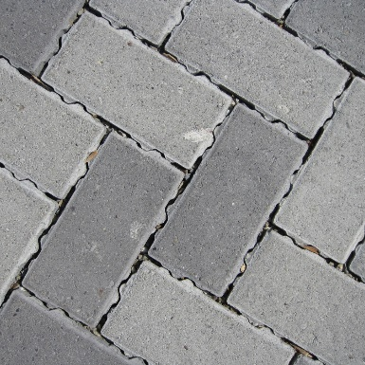
Tools for Public Project Identification and Prioritization
- CCW SWRP Overview
  - Development of Initial Project Opportunity Lists
  - Stakeholder Engagement Process
  - Project Opportunity Identification Tool
- Summarize CCW SWRP criteria for selecting/scoring multi-benefit projects
- Additional criteria used by municipal staff
  - Prioritization Process
- Local staff identification of additional projects
  - Integration with Storm Drain Master Plan
  - Integration with Capital Improvement Project planning process
  - Integration with Complete Streets and other transportation planning processes
  - Additional processes and techniques used for project identification and conceptual design

Maps and Project Lists
- Introduce and summarize the maps and project lists
- Attach the maps and project lists in an Appendix.

Early Implementation Projects
- Provision C.3.j.i.(2)(j); TRT Item 14

Review of Capital Improvement Projects
MRP Provision C.3.j.ii. requires that [Permittee] must prepare and maintain a list of public and private green infrastructure projects planned for implementation during the 2015- 2020 permit term, and public projects that have potential for green infrastructure measures. The [Permittee] submitted an initial list with the FY 15-16 Annual Report to the RWQCB and updated the list in the FY 16-17 and FY 17-18 Annual Reports.
“The [Permittee] submitted an initial project list with the FY15-16 Annual Report, and updated the list in the FY 16-17 and FY 17-18 Annual Reports. OR The [Permittee] is moving forward with incorporation of green infrastructure elements in the [___________] capital improvement project.”
The creation and maintenance of this list is supported by guidance developed by BASMAA: “Guidance for Identifying Green Infrastructure Potential in Municipal Capital Improvement Projects” (May 6, 2016). The BASMAA Guidance is attached to this document as Appendix [_].
- Note any local adaptations to the processes described in the BASMAA document.
- Document current local implementation of this process.
- Identify planned changes or needed improvements.

List of Projects Identified
CIP Projects with Green Infrastructure potential that were identified during 2015-2019 are listed in Table x, along with their status.
Table x. Capital Improvement Projects with Green Infrastructure Potential (identified 2015-2019)
Project Name | Description | Potential Tributary Impervious Area (SF) | Project Status | Included in Green Infrastructure Plan (Y/N)

Workplan for Completion
- Tasks and timeframes for constructing the projects identified in Section 4.2

Tracking and Mapping Public and Private Projects Over Time
- Provision C.3.j.iv.; TRT Item 15H

Tools and Process
- Development of, and features of, the GIS-based tool initiated in cooperation with ACCWP, to be further developed.
- Tracking necessary to provide reasonable assurance that wasteload allocations, including those for the Hg and PCBs TMDLs, are being met.
- Application and use of this tool by the Permittee.

Results
- Output from the GIS-based tool (implementation of Green Infrastructure measures)

Design Guidelines and Specifications

Guidelines for Streetscape and Project Design
- Provision C.3.j.i.(2)(e); TRT Item 15E
- Description of Guidelines
- Reference to Guidelines (in Appendix or referenced)

Specifications and Typical Design Details
- Provision C.3.j.i.(2)(f); TRT Item 15F
- Description of Specifications and Typical Design Details
- Reference to Specifications and Typical Design Details (in Appendix or referenced)

Sizing Requirements
- Provision C.3.j.i.(2)(g); TRT Item 15G
- Description of “single approach” to GI sizing prepared through BASMAA
- Reference to BASMAA document (in Appendix or referenced)

Funding Options

Funding Strategies Developed Regionally
- Provision C.3.j.i.(2); TRT Item 15C
- Describe and reference BASMAA’s “Roadmap for Funding of Sustainable Streets”

Local Funding Strategies
- Provision C.3.j.i.(2)(k); TRT Item 15D
- Describe the sources of funding which your city is currently pursuing or will pursue for Green Infrastructure Project development. Per the Permit Requirements, this should include an evaluation of prioritized funding options, including, but not limited to, alternative compliance funds, grant monies, new taxes and other levies, and other municipal/Permittee resources.
- Describe how funding for Green Infrastructure Projects becomes incorporated into your city’s municipal budget

Adaptive Management

Process for Plan Updates

Pursuing Future Funding Sources

Alternative Compliance and Credit Trading Investigations

Order R2-2015-0049

